2.02.07 Estimation (Degree of Completion)
The estimation mask allows you to assign key figures for project progress. You can make these assignments on any report date. The project status is determined by the variance between the plan/actual comparison and the percentage of completion of a project.
The document category consists of the following elements:

General Data
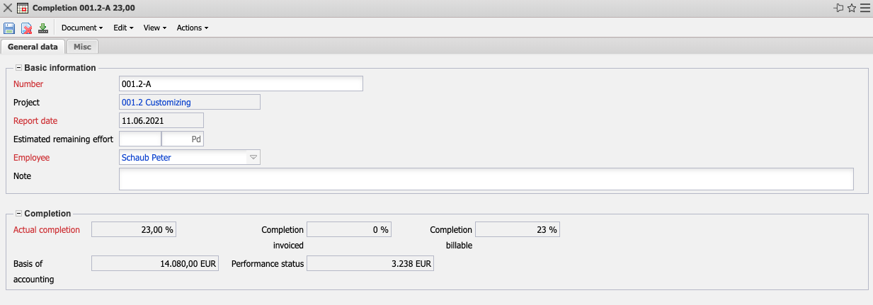
- Basic Information:
  - Number: This alphanumeric field indicates the unique number of the degree of completion.
  - Project: In this field, you select the project for which you want to provide an estimate of the degree of completion. The projects can be defined and changed in the mask project.
  - Report Date: The field Report date indicates the date on which the estimate of the degree of completion was made. The system automatically enters the current date in this field.
  - Remaining Effort: This field is either the entry for the remaining effort and from this the system determines the percentage of completion or (if the percentage of completion is entered) the remaining effort is displayed here.
  - Employee: This field indicates the employee who estimated the percentage of completion. Employees can be managed in the mask Employees.
  - Comment: This field allows you to enter comments on the percentage of completion.

Misc
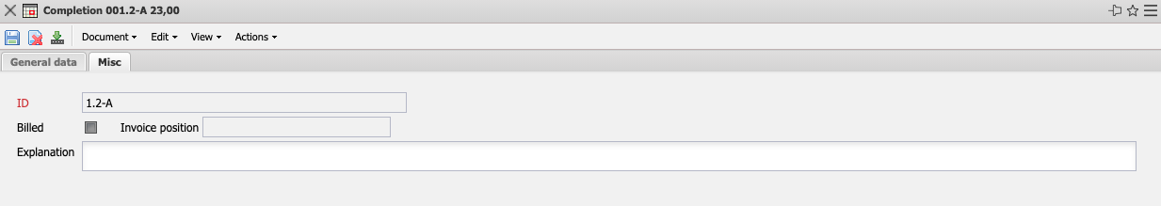
- Number: This field displays the number of the completion. The number is automatically assigned alphabetically by the system.
- Billed: Indicates whether the percentage of completion has been used for invoicing.
- Invoice Position: This field is automatically linked to the A/R invoice for partial invoices.
- Explanation: This field allows you to enter an explanation of the completion.

