2.02.04 Milestone
The Milestone mask manages the milestones of the projects. Milestones define fixed dates by which certain project results must be available in the agreed quality. All relevant information regarding the assignment of a milestone to a project is defined here (milestone date, responsible employee and creation date). The milestones are visualized in the Gantt charts and form the basis of the milestone trend analysis.
The mask consists of the following elements:

General Data
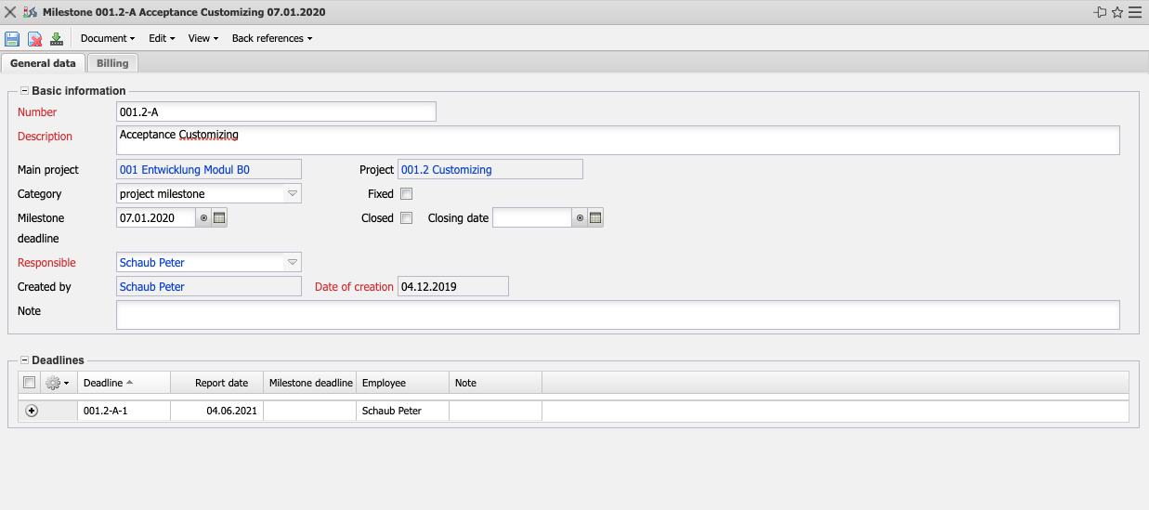
- Basic Information:
  - Number: This field identifies the milestone by means of a unique identifier.
  - Description: The Description field is used to specify the milestone in more detail.
  - Main Project: This field identifies the created main project.
  - Project: This field identifies the project to which the milestone is assigned. Milestones must always be assigned to projects or sub-projects. It is not possible to assign them to work packages. Projects can be defined and changed in the project mask.
  - Category: In this selection field, the category of the milestone is defined (work results, management milestone, project milestone, quality gate).
  - Fixed: If this flag is set, the milestone is not moved when performing a forward or backward calculation in the project planning.
  - Milestone Deadline: The Milestone date field defines the date by which the milestone should be reached.
  - Closed: This field refers to invoicing by milestone. If a milestone is completed using the indicator, the system creates a partial invoice with the discount or the amount (see also contract and invoice).
  - Responsible: The Person responsible field defines the employee who is responsible for reaching the milestone. The employees are managed in the employees mask.
  - Created by: This field allows you to enter the employee who created the milestone.
  - Date of Creation: The Creation date field indicates the creation date of the milestone. This date is automatically assigned the current date by the system.
  - Note: This field allows you to enter remarks on the milestone.
- Deadlines: This field allows you to create deadlines for the milestones.

Billing
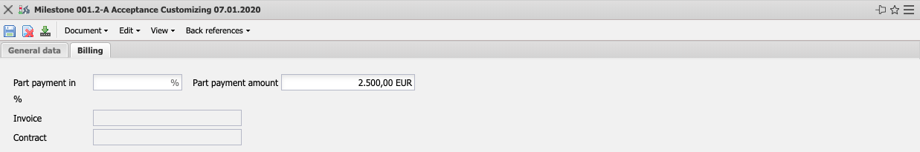
- Part Payment in % and Part Payment Amount(Part of the Billing Module): These two fields refer to invoicing by milestones. If a milestone is completed using the indicator, the system creates a partial invoice with the budget billing amount or the discount (see also contract and invoice).
- Invoice: The description (invoice number) of the created invoice is displayed in this field.
- Contract: The description of the belonging contract is displayed here.

