2.02.03 Job
The mask Job manages the individual work packages of the projects. Jobs are the lowest level in the work breakdown structure and assign exactly one employee an activity (task/operation) for which this employee is responsible within the project. A job can be assigned to a sub-project as well as to a super- and/or main project. This mask shows the time period, the planned effort and the already invoiced time of the work packages, as well as the actual end. For online time recording, it is possible to sort the work package either by priority or due date (plan end).
The screen consists of the following elements:

General Data
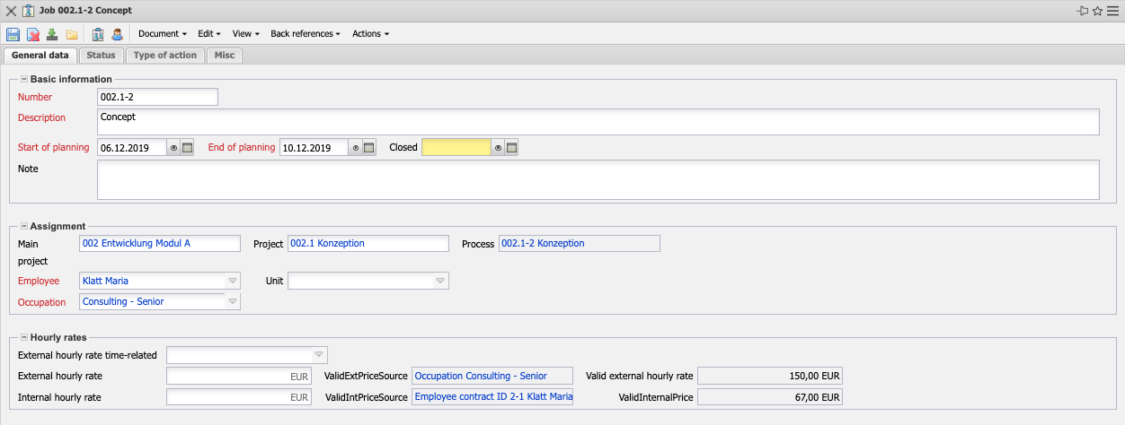
- Basic Information:
  - Number: these alphanumeric fields are the numbers of the defined work packages and are usually derived from the corresponding project number.
  - Description: This field indicates the work package description.
  - Start of Planning/End of Planning: The plan start field indicates the start for processing the work package and is determined by the plan start of the assigned project start. The Plan end field indicates the due date of the work package and is preset with the plan end of the project end.
  - Closed: This field indicates the completion date of the work package. The work package must be completed by the processor or project manager after the tasks have been completely processed. A work package must be completed either in the document itself or from the time recording component.
  - Note: This field allows you to enter comments on the work package.
- Assignment:
- Main Project: This field is used to enter the main project.
- Project: This field defines the project to which the defined work package belongs. A work package can be assigned to both a main project and a sub-project. The projects can be defined and changed in the document type Projects. Remark: A work package does not necessarily have to be assigned to a project; however, work packages without a project are only considered for employee-related evaluations and not for project evaluations.
- Process: Linking the work package to the corresponding task.
- Employee: This field defines the processor of the work package. The employees can be defined and changed in the document category Employees. Using this assignment, the system will only display the work packages for which the employee is responsible and which have not yet been completed, to each employee during service entry.
- Unit: A unit responsible for the work package can be entered here. In the next version, the work package can also be assigned to this unit only. This organizational unit is defined in the unit mask.
- Occupation: This field defines the activity of the employee within the work package. This activity usually determines cost and pricing and is also used for the suggestion system. The activities can be defined and changed in the document category Activities.
- Hourly Rates:
  - External Hourly Rate Time-Related: Here you can enter the external hourly rate of the job if the hourly rate differs from the normal pricing.
  - Ext. Hourly Rates: If the hourly rate differs from the normal pricing, you can enter the external hourly rate for the job here.
  - ValidExtPriceSources: This field shows which external hourly rate is used for this job.
  - Valid External Hourly Rate:
  - Internal Hourly Rates: The internal hourly rate of the work package can be entered here if the hourly rate differs from the normal cost determination. For example, for job of external employees, travel times or on-call times.
  - ValidIntPriceSources: This field shows which external hourly rate is used for this job.
  - ValidInternalPrice:

Status
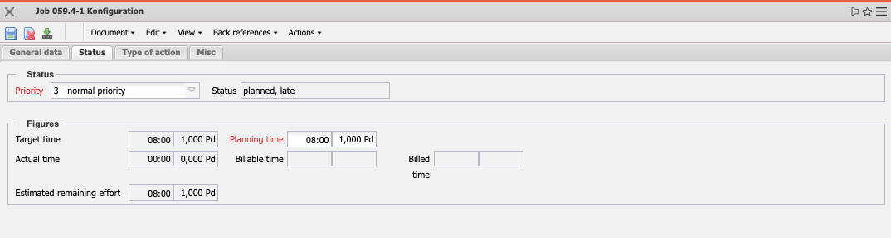
- Status:
  - Status: In this field you can enter the processing status for the work package. The following selections are possible (Completed, Entered, In work, Late). This field can be filled by the user.
  - Priority: This field indicates the priority of the selected work package. The higher the priority, the higher the work package is displayed (if the display is to be based on the priority criterion).
- Figures:
- Target Time: This field is determined by the system during planning and defines the expected project duration in hours or days. During planning, this value is updated (analogous to the planned effort) and when planning is completed (status transition to “advance work” or “active”), this value is not changed.
- Planning Time: This field defines the estimated net time effort of the work package. The cumulated plan values of all work packages of a project are the basis for costing and controlling (plan/actual comparisons).
- Actual Time: The content of this field shows how many hours have been posted to this work package so far in the time recording component.
- Billable Time: This value shows the billable effort of the work package. This value can be entered in the time recording component or in the “"Billable Hours"” dialog.
- Billed Time: This field displays the number of hours that have already been billed in the invoices for the project. This field is determined automatically when the invoice is billed.
- Estimated Remaining Effort: This field shows the last defined remaining effort in hours from the TimeTracker entry component. The value from the work packages is cumulatively transferred to the projects.

To Do
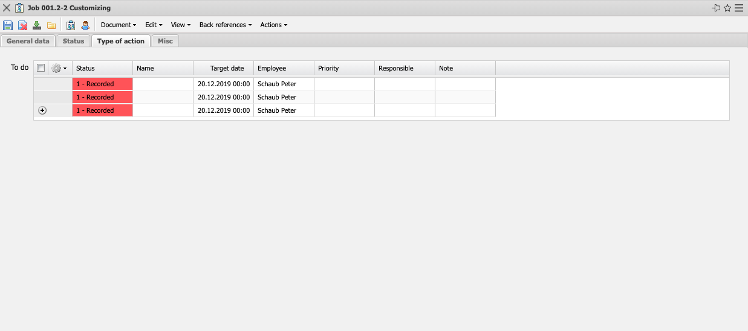
- To Do: Any number of to do's with different specifications can be created in these fields.

Misc
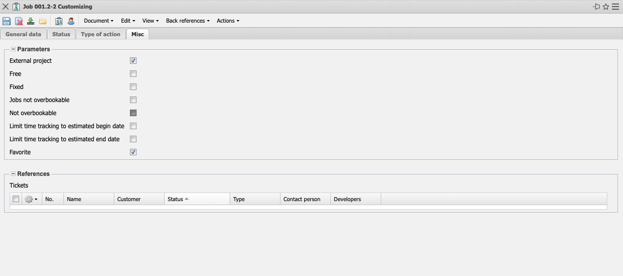
- Parameters:
  - External Project: This field indicates whether the job is external, that is, billable. If the selection box is activated, the selected job is an external task, otherwise it is an internal one. This selection is preset for all job for external projects.
  - Free: This element marks the job as a free task. If this indicator is set, any employee can, in principle, adopt this job in the time recording component (TimeTracker).
  - Fixed: This checkbox can be used to specify that the job is fixed. This functionality is required for top-down planning or when fixing projects in project planning. This functionality is used within forward or backward planning to protect these elements from being shifted (see also Section Scheduling).
  - Jobs not Overbookable: If this field is set, an entry about the planned effort in the time tracker is prevented by a corresponding message.
  - Not Overbookable: This indicator controls the properties of the work packages in the operation. If this indicator is set, you can only enter data for the work packages in the time tracker as long as the planned effort has not been exceeded.
  - Limit Time Tracking to Estimated Begin Date: This indicator controls the properties of the work packages in the project. If the indicator is set, you can only record time in the time tracker for the work package if the start of the work package has been reached.
  - Limit Time Tracking to Estimated End Date: This indicator controls the properties of the project work packages. If the indicator is set, you can only record time in the work package's time tracker as long as the end of the work package has not been reached.
  - Favorite: This indicator is required for favorites management in the TimeTracker.
- References:
- Tickets (Optional): When using the “Product Documentation” module, links to the product structure and change requests can be stored here..

Actions
The document class contains the following actions:
- Suggestion System: You can use this action to create a proposal list for processing the defined work package. The system uses the activity and the time period to determine all employees who are suitable for this task based on their skills and displays their capacities in the relevant time period..
- Display Hourly Rates: Use this action to display the internal and external allocation rates and see where they are stored.
- Edit Process: You can use this action to open the dialog for processing operations. Here you can edit basic values for the operation, assign several employees for the work package and view the workloads of the employees.
- Negate Favorite Flag: This action sets the favorite flag (see above) if it was not set or removes the flag if it was set. This action can be assigned rights using an ACL.

