2.02.02 Process
The Process mask manages the tasks of the projects. In projectile, operations are the grouping of jobs. This mask shows the activity, the period and the expenses (plan, target, actual, rest, billable, invoiced).
The mask consists of the following elements:

General Data
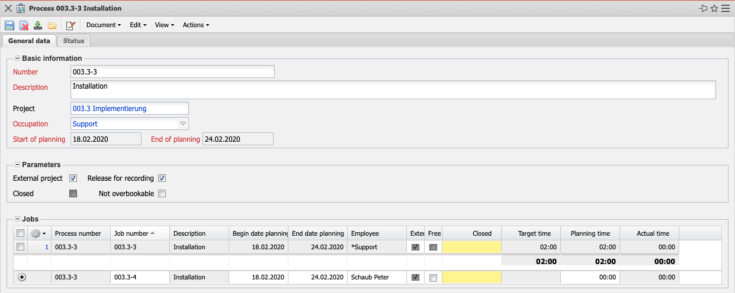
- Basic Information:
  - Number: This element identifies the task as a process. In projectile, an activity is a grouping of one or more work packages that contain the same activity and the same time period.
  - Description: This field identifies the process description.
  - Project: This field defines the project to which the defined task belongs. An activity can be assigned to a main project as well as to a sub-project. The projects can be defined and changed in the document type projects.
  - Occupation: This field defines the activity of the employee within the task. This activity usually determines cost and price determination and is also used for the suggestion system. The activities can be defined and changed in the document category activity.
  - Start of Planning/End of Planning: The field plan start indicates the start of the processing of the activity and is determined by the plan start of the earliest work package assigned and the field Plan end indicates the due date of the work package and is preset with the plan end of the latest work package assigned.
- Parameters:
  - External Project: This field indicates whether the operation is external, that is, billable. If the selection box is activated, the selected operation is an external task, otherwise it is an internal one. This selection is preset for all activities in external projects.
  - Release for Recording: This indicator is preset and, if deactivated, allows projects that are active in work packages NOT to be entered.
  - Closed: This indicator is set automatically by the system when all assigned work packages have been completed.
  - Not Overbookable: If this indicator is set, no more times can be entered for the work packages in this operation in the total than are scheduled in the operation.
- Jobs: This element contains a list of all jobs assigned to the operation.

Status
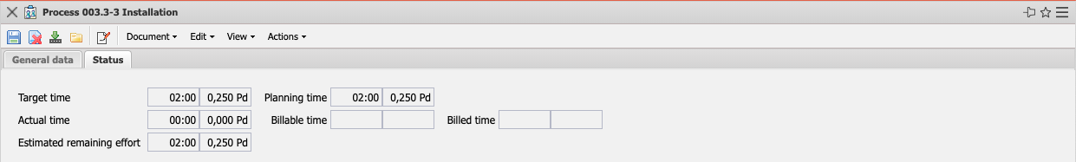
- Target Time: In this field, the estimated net time expenditure of the operation is defined. The cumulated planned values of all activities in a project are the basis for cost and controlling (planned/actual comparisons).
- Planning Time: This field is determined by the system during planning and defines the estimated project duration in hours or days. During planning, this value is updated (analogous to planned effort) and when planning is completed (status transition to “advance work” or “active”), this value is not changed.
- Actual Time: The content of this field shows how many hours have been posted to this task in the time recording component so far.
- Billable Time: This value displays the billable effort of the activity. This value can be entered in the timetracker or in the dialog “Billable times”.
- Billed Time: This field displays the number of hours that have already been billed in the invoices for the project. This field is determined automatically when the invoice is billed.
- Estimated Remaining Effort: This field shows the last defined remaining effort in hours from the TimeTracker entry component. The value from the work packages is cumulatively transferred to the Projects.

Actions
The document class contains the following action:
- Edit Process: You can use this action to open the dialog for case processing. Here you can, among other things, edit basic values of the case, assign several employees for the work package and view the employee workloads.
- Complete Process: This action is used to close the process.

