2.02.01 Project
The project mask manages the project master data in the system. The project structure, i.e. the division into projects and sub-projects, can be defined here. Basically, each project can consist of a finite number of sub-projects and hierarchy levels.
In the mask, all relevant information about the project and its relationship to the parent project (its hierarchical position in the project structure), the activity, customers, currency, project hourly rate, project manager, the necessary qualifications, assignment to the project team, cost center and asset data are defined. In addition, the planned values for project start and end, the project budget, the project costs, and the project duration are displayed here for the project manager.
Note: For the projects (analogous to the units) functional authorizations can be defined (see also administration guide)!

General Data
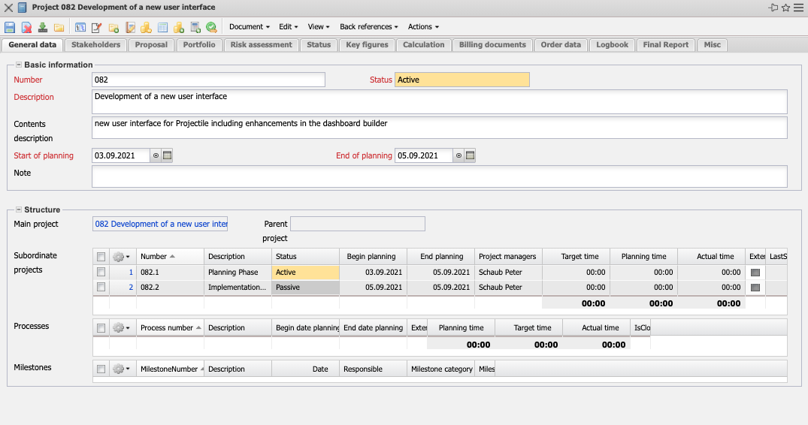
- Basic Information:
  - Number: This alphabetical field uniquely identifies the project in the system. The project number can be changed at any time, but must be unique in the database. This number is usually preset with a number range and is inherited by all project-related elements (subprojects, work packages, milestones, etc.).
  - Status: This field indicates whether the project is active, passive or completed. When you create a new project, the system defaults this field to passive. Further characteristics (interrupted, terminated) can be defined by the administrator.
  - Description: In this field a summarizing description of the project can be entered.
  - Start of Planning/End of Planning: The Plan Start field defines the expected project start and the Plan End field defines the expected project end. An entry for these fields is mandatory. This forms the basis for the evaluations (Gantt diagram, milestone trend analysis, ...) of the information system.
  - Note: Further comments on the project can be entered here.
- Structure:
  - Main Project: The highest organizational unit of a project structure. It does not itself have a superordinate project.
  - Parent Project: The field Superior Project characterizes the existence of a superordinate project. If the element is not occupied, then the project itself is a superordinate project. The project structure is displayed using the project structure plan. When you create subprojects, this entry is filled automatically.
  - Subordinate projects: This element contains a list of all assigned subprojects. After defining subprojects, they are automatically transferred to the parent project as subprojects.
  - Processes: This element contains a list of all assigned work packages or processes.
  - Milestones: This element contains a list of all assigned milestones.

Stakeholders
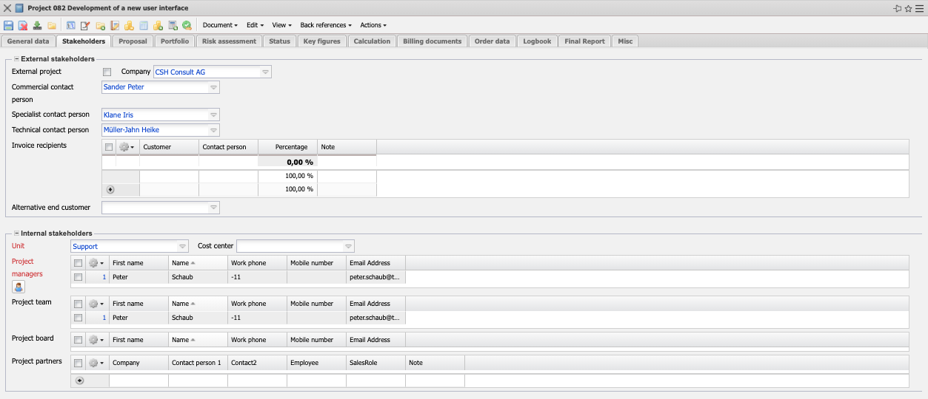
- External Stakeholders:
  - External Project: This field indicates whether the project is external. If the checkbox is activated, the selected project is an external project, otherwise it is an internal project. For external projects, the system requires the assignment of a sold-to party.
  - Company: The contact of the project can be entered in this field.
  - Commercial/Specialist/Technical Contact Person: The field Contact Person identifies the contact person for the project. After selecting a customer, this field is filled with the contact persons of this customer. The contact persons are managed in the contact person mask.
  - Invoice Recipients: If the project invoices are to be split up proportionally among several customers, the individual recipients can be entered here with a percentage. The procedure is as follows: First a normal invoice is created, this is then converted into several invoices with the action “Split invoice” and each recipient receives an invoice with his percentage share. The sum of the individual invoices then equals the total amount again.
  - Alternative End Customer: Here you can enter an end customer that differs from the ordering party.
- Internal Stakeholders:
  - Unit: In this field, you define the responsible unit (usually a location or a department). The heads of these units then have the same authorization for this project as the project managers. Units can be edited in the unit mask.
  - Project Manager: This field identifies the project manager of the project. The project manager automatically becomes project manager of all defined sub-projects. This ensures that the project manager has the authorization to create and change data for this project. Normally, an employee is only granted access to a project once he or she has joined the project team.
  - Project Team: This multiple selection enables the project team to be put together. The project managers of the subprojects and the processors of the assigned work packages are automatically transferred to the project team.
  - Project Board: The members of the steering committee can be entered here.
  - Project Partners: Here you can enter the internal and/or external project partners and their role in the project.

Proposal
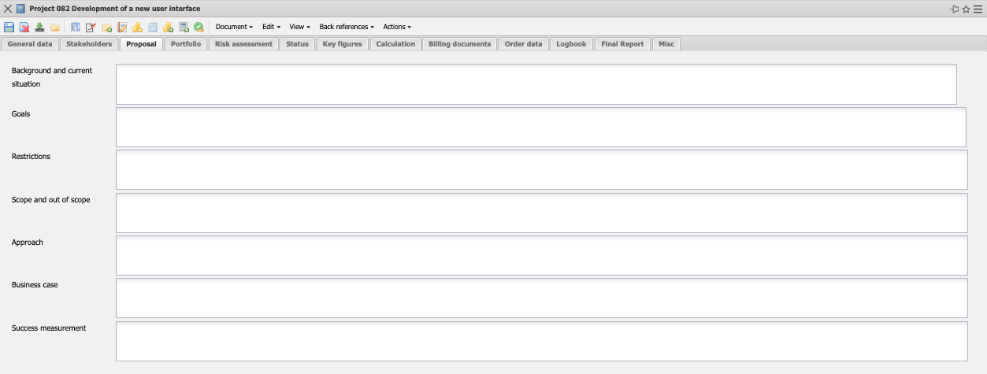
These fields of this tab serve to describe the project proposal.

Portfolio
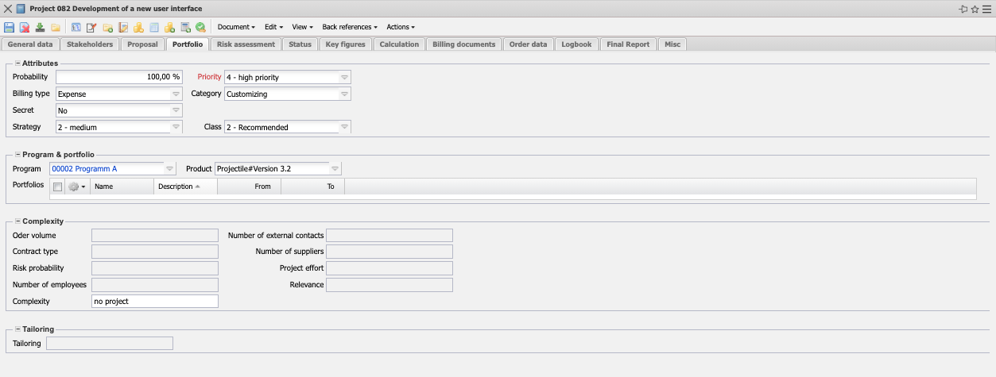
- Attributes:
  - Probability: For passive projects this field indicates the probability that the planned project will become an active project (=order). This probability is taken into account proportionally in capacity planning and is used in the proposal system. When a project is activated, the system automatically sets this probability to 100%.
  - Priority: This field indicates the priority of the selected project.
  - Order Type: This element serves as an indicator for the later settlement of the project (effort or fixed price). This field is also used in some versions as an indicator for the valuation of finished and unfinished activities.
  - Project Type: This field assigns a definable project type to the project, which can be used as a selection criterion in the evaluations.
  - Strategic Relevance: An evaluation of the project for the strategic relevance to the project landscape can be stored here.
  - Class: Here you can specify whether the project must be made/can/should be made.
- Program & Portfolio:
  - Program, Portfolio: If the defined project is assigned to a portfolio or program, the corresponding element is automatically displayed here or can be selected here.
  - Product: Here the project can be assigned a product (either as a pure entry or as an object product from the product management module).

Risk Assessment
On this tab you have the possibility to make a rough risk planning for the project.
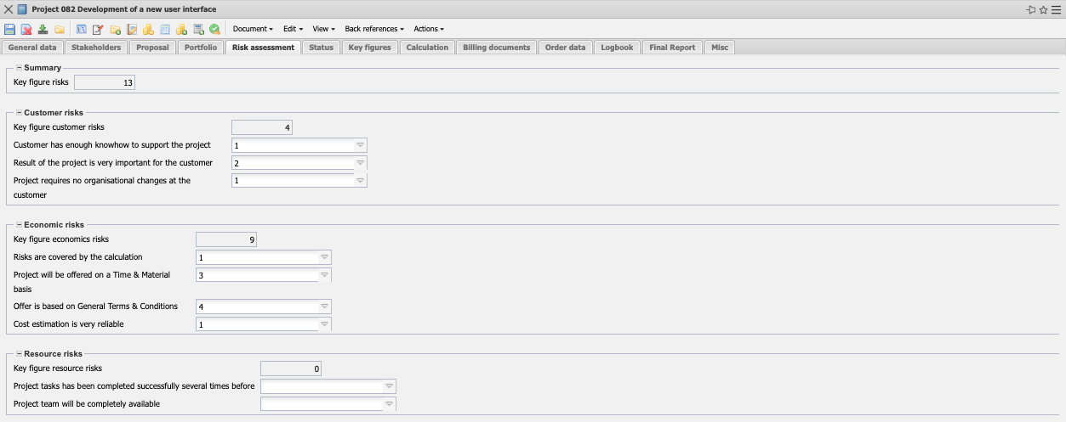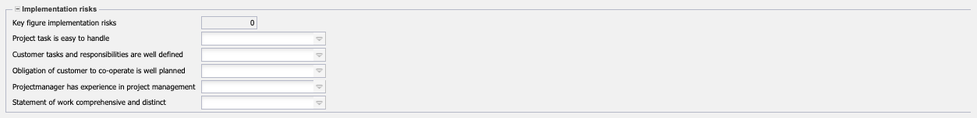
The risk assessment presented is an implementation example and differs from it in many versions. The risks are categorized (here into customer risks, economic risks, resource risks and execution risks) and often include point systems.

Status
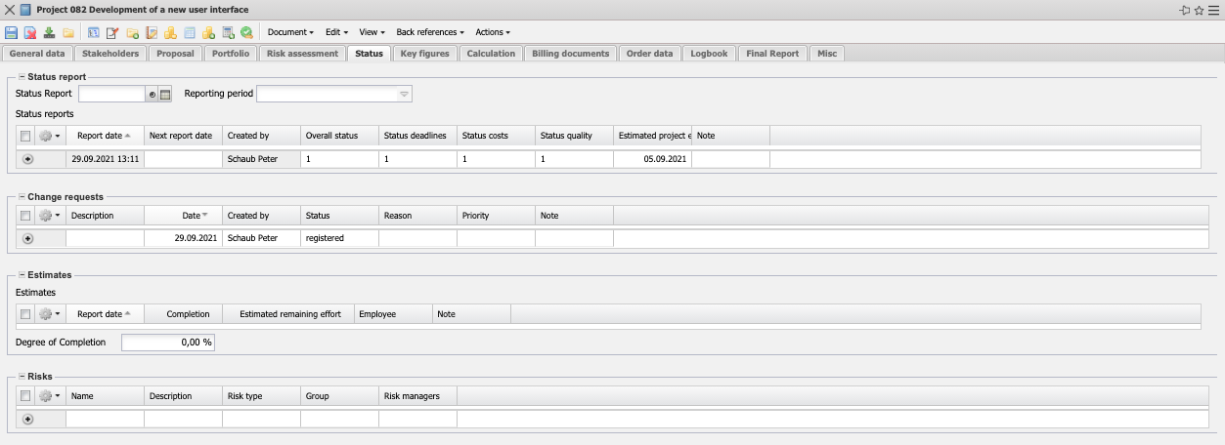
- Status Reports: Status reports are an important part of project management and project controlling. They document the progress of the project plan. The status report often contains status information about dates, costs and quality (sometimes also other information), reasons, progress information (expected project end, remaining costs, ...).
- Project Change Requests:In project change management, a change request is a formalized request to change the properties of a specific product feature. The change request often contains the participants/responsible persons, the priority, a categorization and the quantitative effects (effort, costs, sales, ...) on the project.
- Fertigstellungsgrade: Here the project manager can regularly enter the degrees of completion of the project (for example for controlling or POC valuation).
- Risiken: Here (if the Risk Management module is enabled) the risks are displayed.

Key Figures
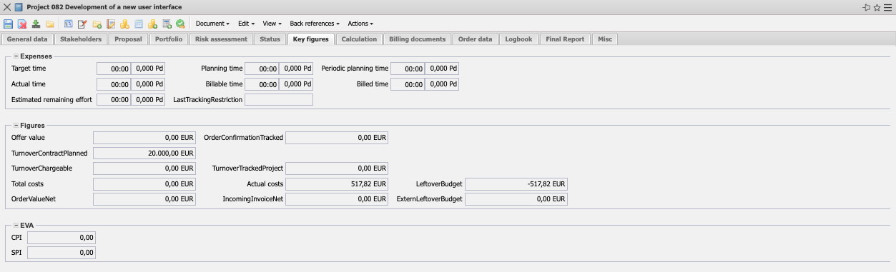
- Expenses:
  - Target Expenditure: This field is determined by the system during planning and defines the expected project duration in hours or days. During planning, this value is updated (analogous to planned effort) and when planning is completed (status transition to “advance work” or “active”), this value is not changed.
  - Plan Effort: This field defines the expected project duration. This field is either determined automatically according to the ButtomUp principle or is specified by the user in Top-Down planning. This value is identical to the planned effort until the status changes to “Advance work” or “active”.
  - Actual Effort: This field contains the recorded times for the assigned project. These actual efforts are transferred to the projects and work packages each time a change is made in the TimeTracker recording component.
  - Billable Effort: This field contains the billable effort for the assigned project.
  - Billed Effort: This field contains the billed times for the assigned project. These billed times are transferred to the projects and work packages each time the invoice is issued or cancelled.
  - Expected Remaining Effort: This field shows the last remaining effort estimate entered minus the subsequently entered effort.

Calculation
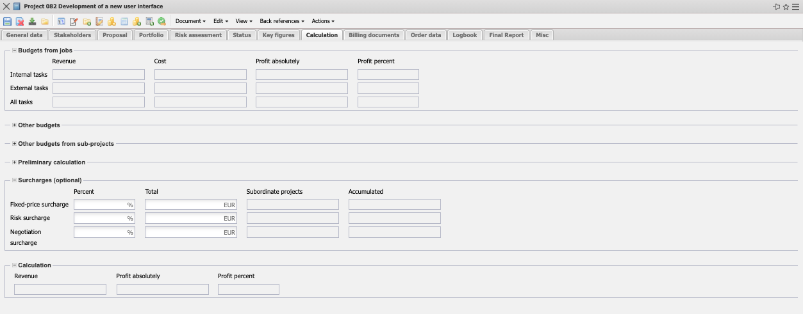
On the “Calculation” tab, the upper frame contains planned sales, planned costs and planned profit (absolute and percentage). These values are calculated on the basis of the work packages. In the next frame other budgets can be managed, e.g. for travel expenses, external consultants and license fees. The lower frame contains the overheads. In most versions, up to three surcharges (absolute or percentage) can be entered. In the standard version, these are surcharges for fixed-price projects, risks (usually in the effort estimation) and negotiation surcharges.

Billing Documents
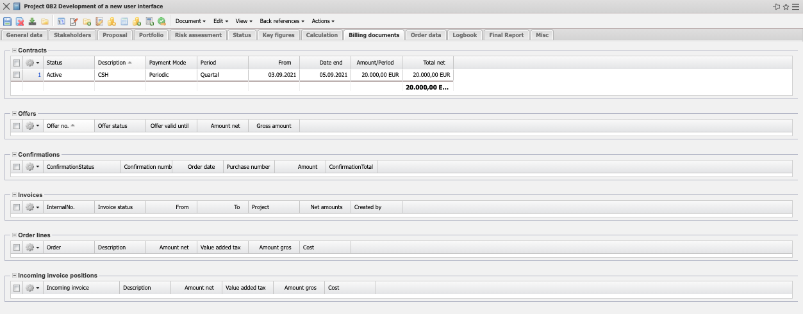
The billing documents (offers, orders, outgoing invoices, ...) of the project are listed here.

Order Data
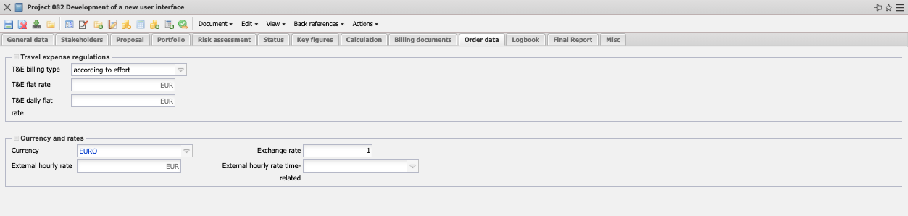
- Order Data:
  - Order Number, Order Date: The order number and order date of the project can be entered here. This order data can be used for the invoice printout. The order number and the order date are automatically transmitted by the system when an order confirmation is accepted in a defined way.
  - Order Value: This field can be used to define the fixed price (maximum upper limit of all invoices for this project). If this order value is defined here, the automatically determined value Planned Sales represents only the theoretical project budget, based on the planned values from the work packages and budget management. The order value is transferred automatically by the system when an orer confirmation is transferred in a defined form.
  - Incoming Order: The type of incoming order (fax, letter, e-mail, ...) can be entered here.
  - Discount: Here it can be noted whether the customer receives a discount.
  - Cash Discount: This field indicates whether the customer receives a discount if he pays the amount immediately.
- Travel Expense Regulation:
  - Travel Expense Settlement Type, Travel Expense Flat Rate and Travel Expense Flat Rate per day: Here you can store the defaults for the settlement of the project's trips (no settlement, per diem, by expense). You can change these default settings per trip.
- Currencies and Rates:
  - Currency: The currency field indicates the project currency. The project currency overwrites the general system currency (see also configuration) and the customer currency (see also Contact). This field is defaulted with the currency from the configuration mask. After selecting a customer, the local currency from the configuration is changed by the customer currency if necessary. The currencies can be defined and changed in the screen currency.
  - Exchange Rate: After selecting a project currency, the Exchange rate field is automatically preset with the valid exchange rate of the project currency to the local currency (see also configuration). Here you can also define a different project exchange rate (e.g. for international projects where the currency risk is to be minimized). This exchange rate is also binding for quotations and invoices. The exchange rates are managed in the exchange rate mask.
  - External Hourly Rate (fixed and variable): These fields indicate the general hourly rate (fixed or variable) for further calculation for the defined project. If this field is filled (and the corresponding field in the work package is not), all work activities are charged with this rate and the system no longer takes into account the rates from the masks contact, employees or activities (see also pricing). The variable rate is higher than the fixed hourly rate.

Logbook
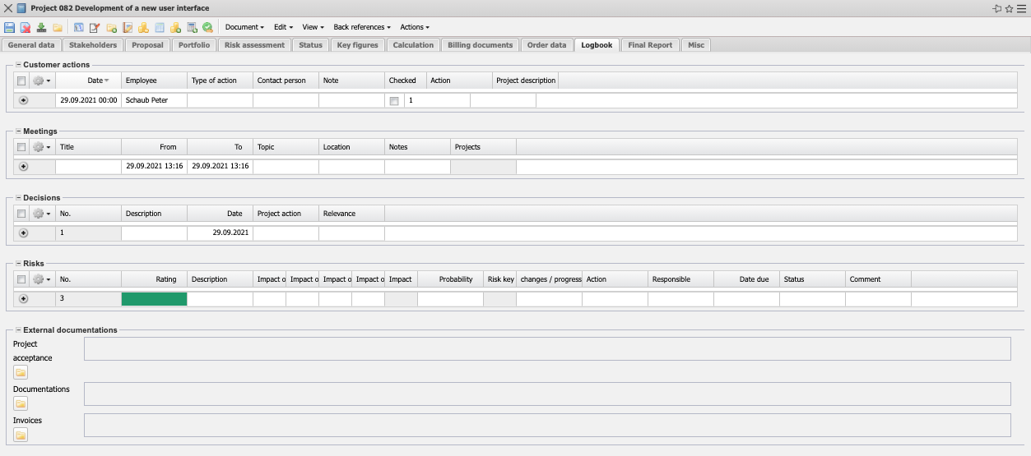
- Actions: In this field, projectations can be entered or assigned.
- Meetings: This field allows to enter or assign meetings.
- Action List: This field allows the entry of events.
- ext. Documentation: If the flyer is available, external files can be assigned here.

Final Report
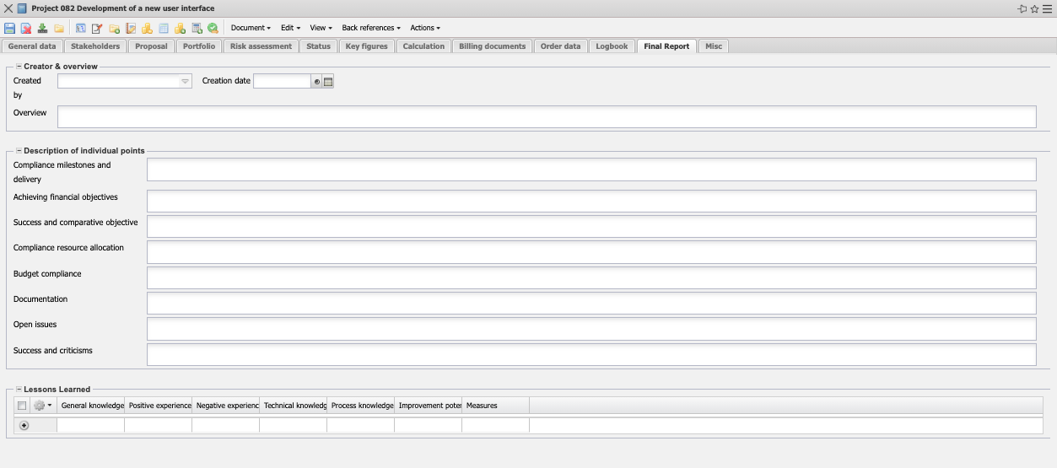
- Creator & Summary: A summary of the final report (Project Closing Document - PCD) can be stored here.
- Description of the Individual Points: Detailed information for the PCD can be entered here.
- Lessons Learned: Lessons Learned can be entered here, which can also be viewed by users without access to the project.

Misc
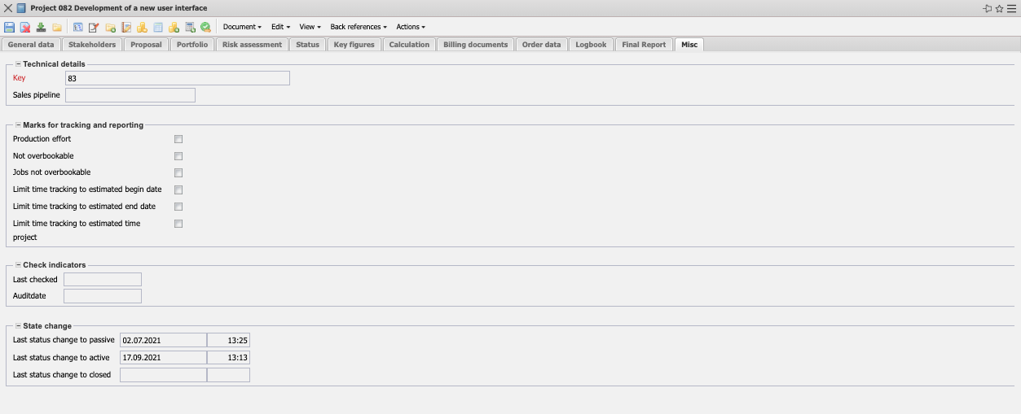
- Technical Setting & Details:
  - int. Key: This numeric field uniquely identifies the project. This number is proposed by the system.
  - Offer Value: The total of all bid values for the project is stored here (net).
  - Invoice Value: The total of all invoice values of the project is stored here (net).
- Indicators for Recording and Reporting:
  - Operational Activity: This indicator controls the properties of the project work packages. This indicator is an evaluation criterion in capacity evaluations and is used, for example, for internal projects or permanent projects so that these projects are not taken into account when calculating the workload of employees.
  - Total of Work Packages in the Activity cannot be Overbooked:: This indicator controls the properties of the activities in the project. If the indicator is set, you can only record in the TimeTracker on the activity (or the total of the assigned work packages) as long as the planned effort is not exceeded.
  - Work Packages cannot be Overbooked: This indicator controls the properties of the project work packages. If the indicator is set, you can only enter data in the TimeTracker for the work package as long as the planned effort has not been exceeded.
  - Time Recording only after the Start of the Plan: This indicator controls the properties of the project work packages. If the indicator is set, you can only record time in the work package in the time tracker if the start of the work package has been reached.
  - Time Recording only before End of Plan: This indicator controls the properties of the project work packages. If the indicator is set, you can only record time in the work package's time tracker as long as the end of the work package has not been reached.
  - Project not Overbookable: This indicator controls the properties of the project work packages. If the indicator is set, data can only be entered in the TimeTracker for the work packages of the project as long as the planned effort of the project is not exceeded.
- Check Indicators:
  - Checked on, Checked on Key Date: The check date of the project and the key date of the check can be entered in these fields.
- Last Status Change to Passive, Active or Completed: The most important status changes are listed here (passive - entered, active/preliminary work, completed/cancelled). The complete history of all status changes can be found in the menu item “View - Show Event Log”.

