2.01.27 Product Group
The mask merchandise category manages the merchandise categories as collective objects for articles in the system. These merchandise categories can be organized hierarchically, that is, each merchandise category can consist of any number of subordinate merchandise categories. The merchandise category can contain information on the vendor, commission and accounts for financial accounting, among other things.
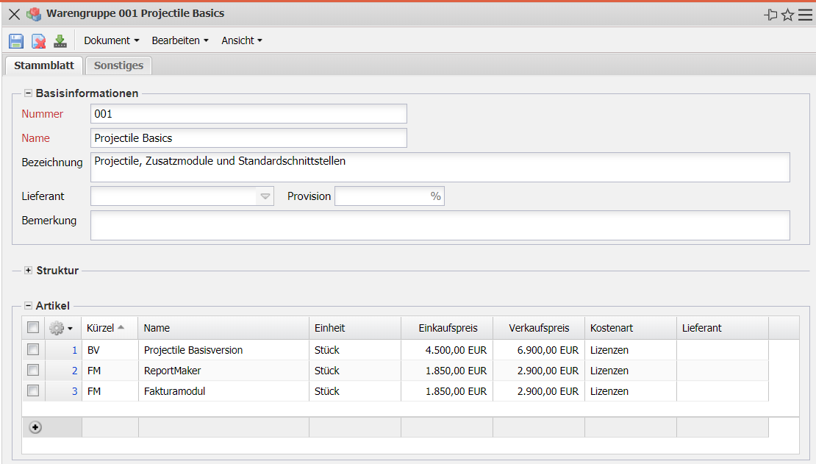
The mask consists of the following elements:

Master Sheet
- Basic Information:
  - Number: This field uniquely identifies the merchandise category.
  - Name: This field identifies the merchandise category. This identifier is used as the short description (50 characters) of the material group.
  - Description: This alphanumeric field identifies the material group. This description is used as the long description (255 characters).
  - Vendor and Commission: This field identifies the vendor of the merchandise category (usually the vendor of all articles in the merchandise category), with the corresponding commission, if applicable. The suppliers are managed in the contacts mask.
- Structure:
  - Superior Merchandise Group: This multiple selection contains all superior material groups (for example product groups).
  - Subordinate Merchandise Group: This multiple selection contains all subordinate material groups.
- Articles: This multiple selection contains all articles in this merchandise category. The articles are managed in the Article mask and can be assigned to the merchandise categories here.
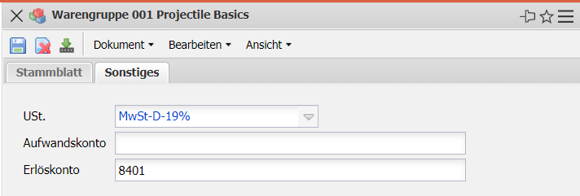

Miscellaneous
- Umsatzsteuer: In diesem Feld wird die Umsatzsteuer für die Artikel der Warengruppe aus dem Auswahlmenü eingetragen. Die Umsatzsteuer kann in der Maske Umsatzsteuer definiert und geändert werden.
- Aufwands- und Erlöskonto: Hier können das Aufwands- und Erlöskonto für Buchungen hinterlegt werden.
- Bemerkung: Dieses Feld ermöglicht die Eingabe von Bemerkungen.

