2.01.26 Unit
The Mask Unit manages the organizational structures of the company. Usually departments and sub-departments (if necessary also locations) with the corresponding employees are defined here. These units are used (analogous to the projects) as a basis for the local authorization system (see also Administration Guide). They can also be used to assign projects to organizational units.
Note: Functional authorizations can be defined for these units (analogous to the project structures) (see also administration guide).
This mask consists of the following elements:

Master Sheet
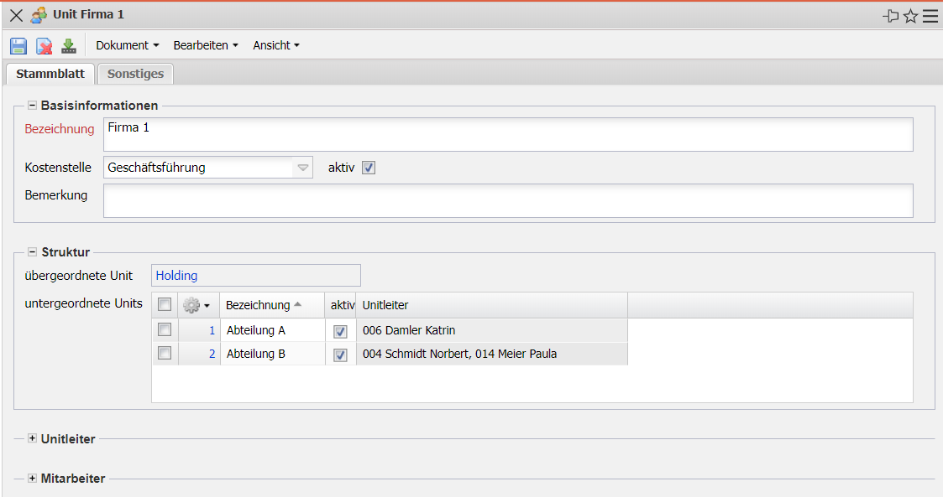
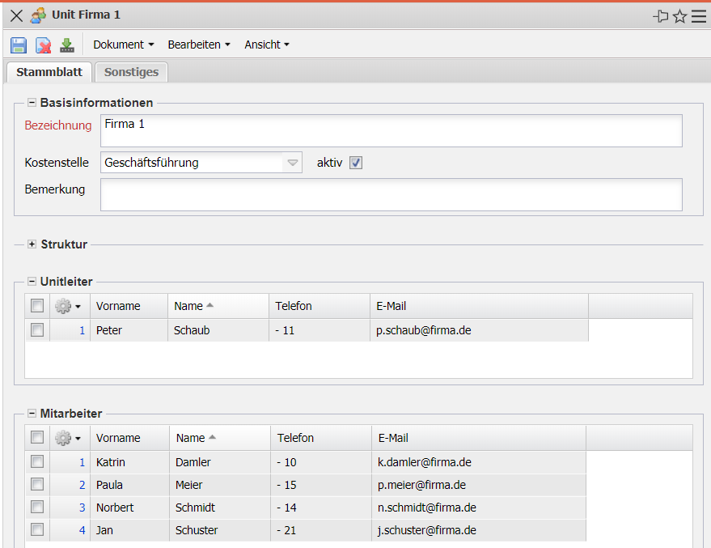
- Basic Information:
  - Description: This field indicates the unit (location, department, subsection, ...).
  - Cost Center: Here you can define the cost center to which the unit is to be allocated.
  - Active: At this point you can mark whether the unit in question is active or not.
  - Comment: This field is used to enter comments.
- Unit Leader: This multiple selection includes the heads/supervisors of the unit (usually heads of department or, if the units are sites, the heads of the sites).
- Structure:
  - Superior Unit: This multiple selection includes all higher-level units (such as main departments or locations).
  - Subordinate Unit: This multiple selection includes all subordinate units (such as subdivisions).
- Employee: This multiple selection includes all employees of this unit/department. In addition to the employees, the system also interprets the unit leaders of the subordinate units as employees of the unit.

Miscellaneous
- int. Key: This alphanumeric field uniquely identifies the unit in the system.

