2.01.23 Employee
The mask employee manages the master data of the individual project members. All information about the employee, such as the personnel number, the assigned user group, the password for logging into the system, the employee status, location, name and address of the employee, department and function, the communication possibilities as well as the data for working time management are stored here.
The mask consists of the following elements:

Master Sheet
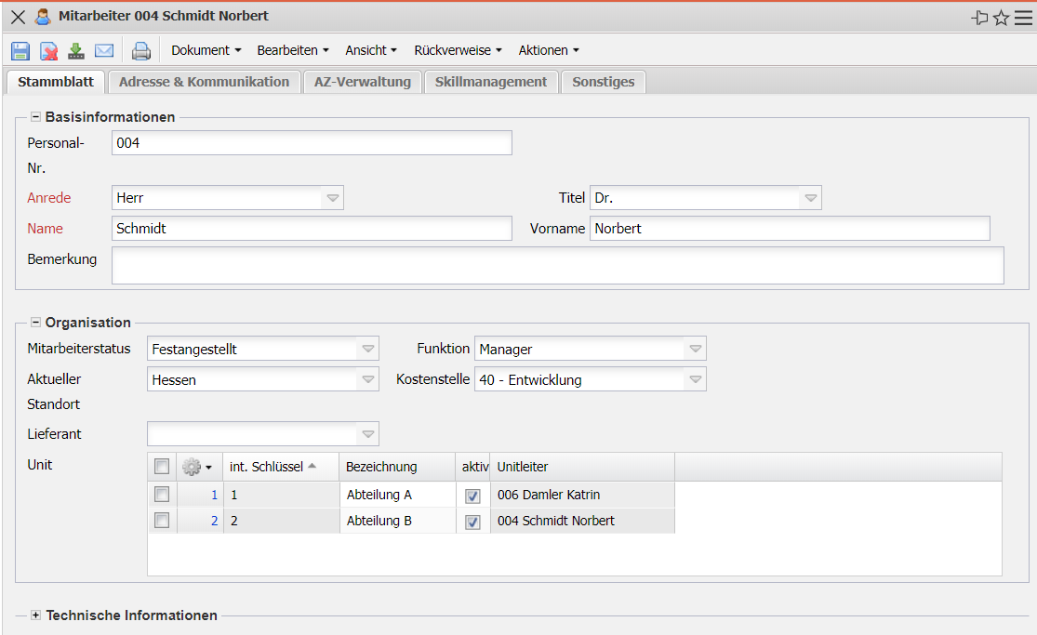
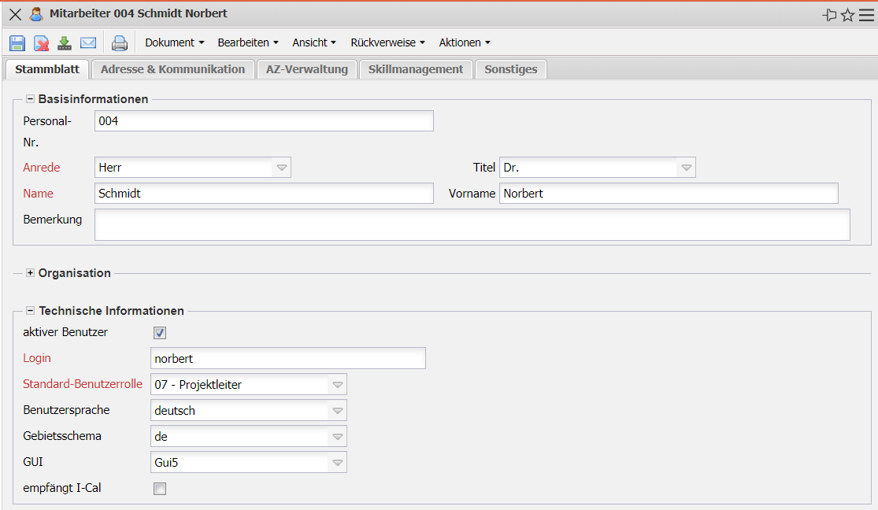
- Basic Information::
  - Personnel Number: This alphanumeric field allows the entry of a personnel number and is of an informal nature.
  - Salutation, Title, Surname and First Name: These fields indicate the salutation or/and the title and the first and last name of the employee. The characteristics for the form of address can be defined and changed in the collections.
  - Comment: This field is intended for comments.
- Organization:
  - Employee Status: The Status field indicates the status of the employee. For example, the characteristics Permanent Employee, Freelancer and External Employee are possible.
  - Function: This field indicates the employee's function within the company. This field can be defined and changed in the collections. The function of the employee can be selected as follows (consultant, developer, distributor, finance, graphic designer, manager, marketing).
  - Location: The Location field indicates the location of the headquarters or branch of the company for which the employee works. The locations can be defined and changed in the collections. The collections for the location can be defined and changed in the calendar mask.
  - Cost Center: This field indicates the cost center of the employee. The cost center can be defined and changed in the collections.
  - Unit: In this field, you can enter the units (organizational units, usually locations and/or departments) to which the employee belongs. These units can then be used as the basis for the local authorization system (see also the administration guide).
- Technical Information:
  - Active User: This field indicates the status of the employee in the system. Only active employees can work with Projectile.
  - Login: This field is relevant for logging on to the system. Each employee must log on to the system using his or her login (ID) and password. By entering the password via the action, the system recognizes the employee and assigns him/her to an appropriate user group. Due to the authorizations resulting from this assignment, the employee is only shown the documents for which he or she has authorization.
  - Standard User Role: The User Group element assigns the selected employee the appropriate authorizations. This ensures that the system will only display the document categories for which the employee has authorization.
  - User Language: In this field you can select the language of the user. These options are: German, English, French and Portuguese.
  - Locale: This field determines the display of the numerical values according to the currently selected language.
  - GUI: This field indicates which graphical user interface the employee uses.
  - Receives I-Cal: This field indicates whether the employee receives I-Cal.

Address & Communication
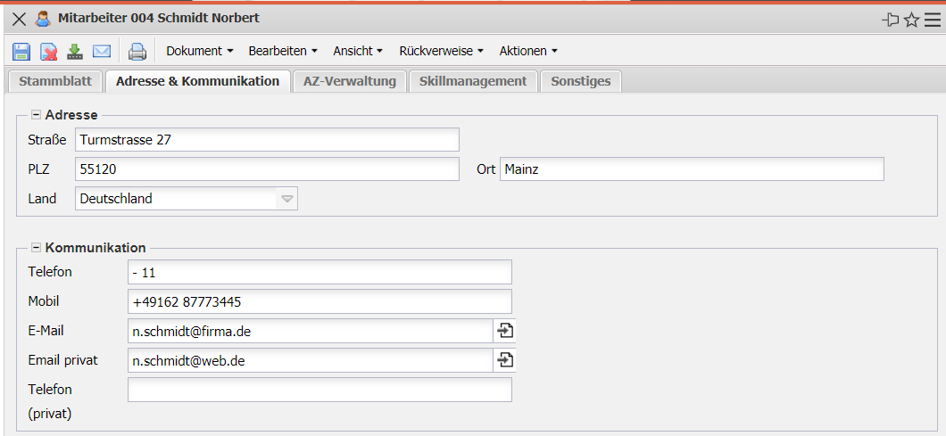
- Address:
  - Street, Postal Code, City and Country: These fields indicate the employee's complete address. The country can be defined and changed in the collections.
- Communication:
  - Phone, Mobile and e-mail Addresses: These fields indicate the employee's availability by telephone (office, private, and mobile) and by e-mail. Clicking on the e-mail address opens the user's standard mail program with the e-mail address entered. The e-mail address is also relevant for the time services function.

AZ Management
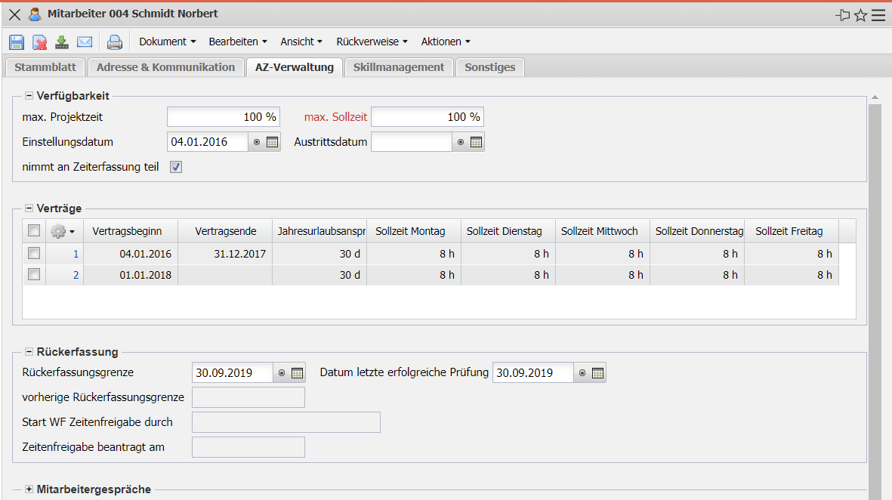
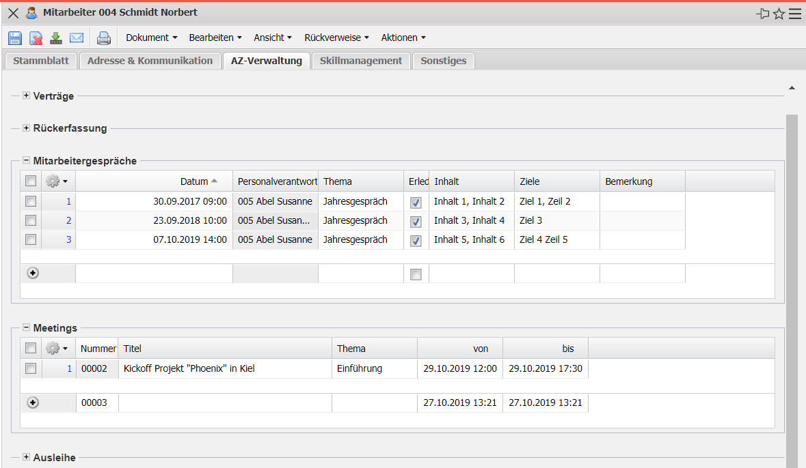
- Availability:
  - Max. Project Time: This field specifies the maximum capacity for project work of an employee. This percentage therefore represents the maximum proportion at which an employee can/should be scheduled in projects. This upper limit is displayed when you put together a project team in the suggestion system.
  - Max. Target Time: This field indicates the maximum working time of an employee (100% corresponds to full time; 50% corresponds to a half-day job, and so on).
  - Hiring, Leaving: These fields indicate the hiring and leaving date of the employee.
  - Participates in Time Recording: This field indicates whether the employee participates in time recording.
- Contracts: In this multiple selection, the contracts for the employees are determined. Contracts can be defined for a specific period (see also Working Time Management).
- Performance Reviews: This field enables you to list all the performance reviews that have been held.
- Lending: Here you can manage the lending of equipment (smartphones, company cars, notebooks, ...) (not standard).
- Meetings: This field allows you to manage meetings.
- Recapture:
  - Re-entry Limit and Previous Re-entry Limits: Date of the last or penultimate re-entry limit.
  - Start WF (Workflow) Time Release by: Employee who started the “period-end closing” workflow (usually the employee himself).
- AZ Management:
  - Overtime Regulation: Here you can manage deviations from the employment contracts for the employee on the basis of the calendar (not standard).

Skill Management
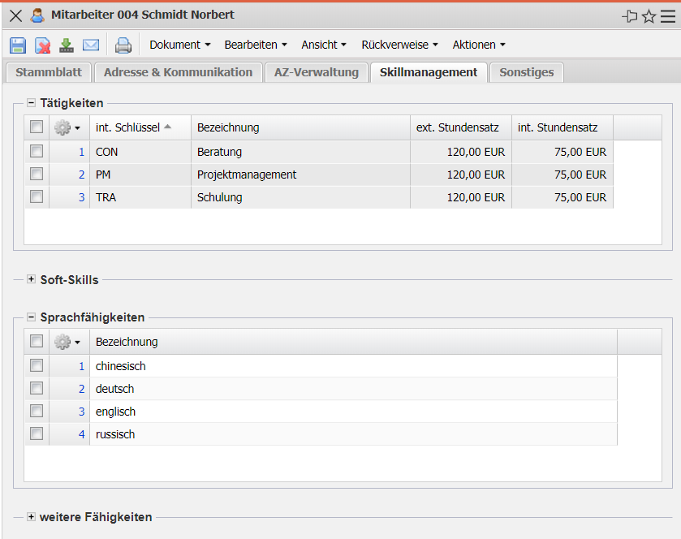
- Activities: This field enables you to assign activities for the suggestion system. This suggestion system supports the user in project planning using the project templates or in the manual definition of work packages (only those employees who have assigned the required skills/activities are then optionally displayed).
- Soft Skills, Language Skills: These fields allow the assignment of further skills of the employee.

Miscellaneous
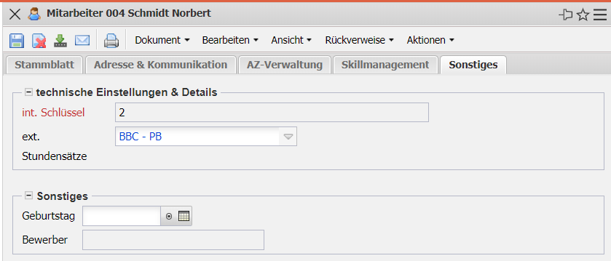
- Technical Settings & Details:
  - int. Key: This alphanumeric field uniquely identifies the employee in the system.
- Miscellaneous:
  - Birthday: This field indicates the employee's birthday.
  - Applicant: This field links to an applicant created by the employee and allows you to access the applicant's data using this link.

Actions
This document type contains the following actions:
- Set Password: This action is used for the employee's login, to log on to the system.
- Display User Settings: This action displays the personal settings of the user.
- Display Initiated Workflows: This action allows the logged-in user to access workflows that are still in the future.
The following actions are available:
- Add Contract: This action creates the employee contract.
- Add Time Bookings: This action creates new time postings for the employees.
- Display Employee Time Bookings: This action displays all employee time postings for this employee.

