2.01.17 Customerwise Occupation
The mask Customerwise Occupation manages the charging and invoicing rates (per hour), which are used differently from the standard rates (usually defined in the activities) for a specific customer.
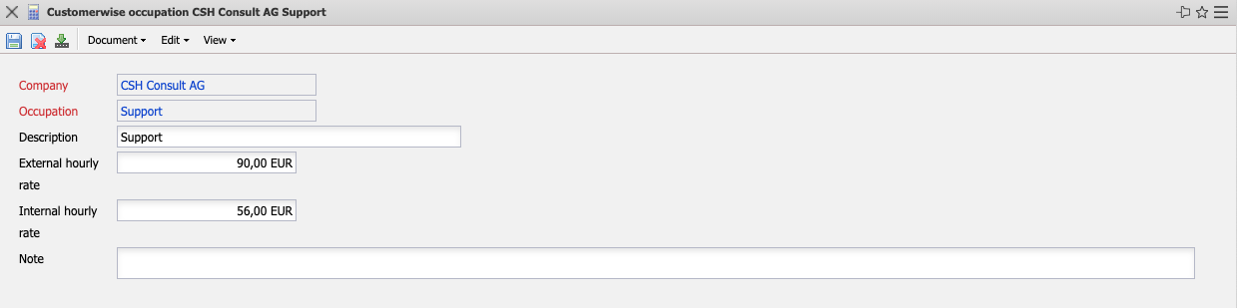
The mask consists of the following elements:
- Company: In this field, the system automatically defaults the activity-related contact.
- Occupation: This field indicates the created customer-related activity, in which the upper and lower activities can also be created.
- Description: This field indicates the description of the activity.
- External Hourly Rate: This field indicates the external calculation rate per hour of this activity. This rate is then (if there is no project-related change) used for offers and invoices.
- Internal Hourly Rate: In this field the internal billing rate per hour for the customer is defined. However, this rate for cost accounting is only used if no project-related allocation rate or employee-related rate is defined in the system.
- Note: This field is used for entering remarks.

