2.01.15 Sales Pipeline
The Sales Pipeline mask manages the possible orders in the system. Here, classifications can be made and the need for action, the sales phase, the order probability, the presumed order value and the total budget can be entered.
The mask consists of the following elements:

General Data
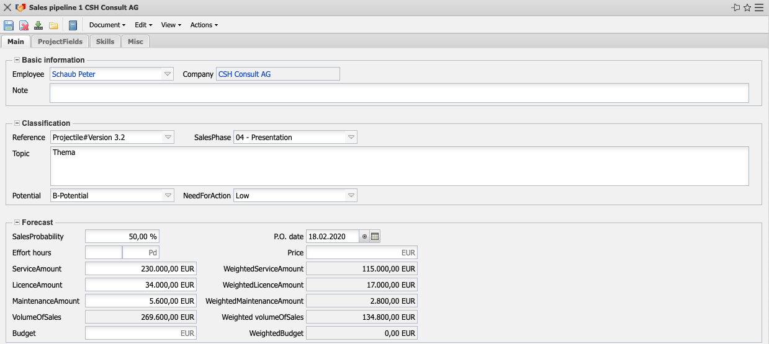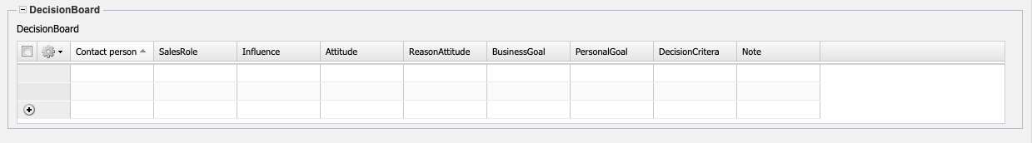
- Basic Information:
  - Employee: This field indicates the person who entered the sales funnel. The employees can be defined and changed in the document category employee.
  - Company: This field assigns the sales funnel to the corresponding contact.
  - Note: A comment on the sales funnel can be entered here.
- Classification:
- Reference: The reference types stored in the collection can be defined and selected in the Reference field (for example, training courses, workshop, and so on).
- SalesPhase: In the Sales Phase field, you can define and select the sales phases defined in the collections (see administration guide) (for example, first contact, qualified contact, information material, presentation, quotation, and so on).
- Topic: The subject of the sales funnel can be entered in this field.
- Potential: In the Potential field, you can store the gradations defined in the collections (see administration guide) with regard to the quality of the business contacts (for example, A, B or C contacts).
- NeedForAction: In the Need for Action field, you can enter the levels defined in the collections (see the administration guide) with regard to the need for action by the interested party (for example, Low, Significant, Mandatory, and so on).
- Forecast:
  - SalesProbability: The order probability of the sales activity is stored here.
  - P.O. Date: The time of the presumed incoming orders of the sales activity is stored here.
  - Effort Hours: For service projects, the potential effort in hours (or man-days) can be entered here.
  - Price: For service projects, the potential hourly rate can be entered here.
  - ServiceAmount: A potential order value for services can be entered directly here.
  - WeightedServiceAmount: The potential order value for services is displayed here, taking into account the order probability.
  - LicenseAmount: The potential order value for services is displayed here, taking into account the order probability.
  - WeightedLicenseAmount: The potential order value for licenses under consideration of the order probability is displayed here
  - MaintenanceAmount: A potential order value for maintenance can be entered here directly.
  - WeightedMaintenanceAmount: The potential order value for maintenance is displayed here, taking into account the order probability.
  - VolumeOfSales: The potential order value of the sales activity is stored (or calculated) here.
  - WeightedVolumeOfSales: The total potential sales order value, taking into account the sales order probability.
  - Budget: The overall budget of the sales activity can be stored here.
  - WeightedBudget: The potential total budget is displayed here, taking into account the order probability.
- DecisionBoard: Any number of decision makers with their settings for the distribution funnel can be stored here. These persons and their settings can be defined in the document decision makers.

Project Creation
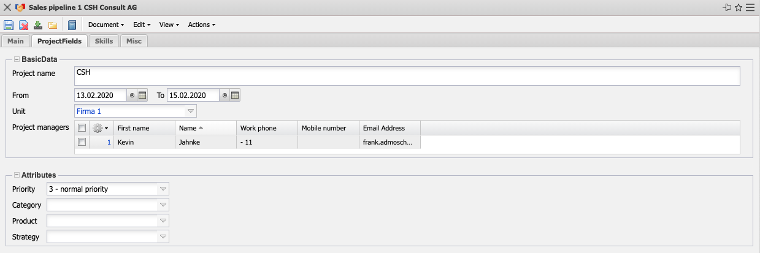
- Basic Data:
  - Project Name: This field identifies the future project.
  - From/To: The field “from” defines the expected project start and the field “to” defines the expected project end of the potential project.
  - Unit: This field defines the unit responsible for the later project (usually a location or a department). Units can be edited in the Unit mask.
  - Project Manager: This field identifies the potential project manager of the later project.
- Attributes:
- Priority: This field indicates the priority of the potential project.
- Category: This field assigns a definable project type to the project, which can be used as a selection criterion in the evaluations.
- Product, Strategy: These fields classify the future project and are selection criteria for portfolio management and project evaluations.

Skills
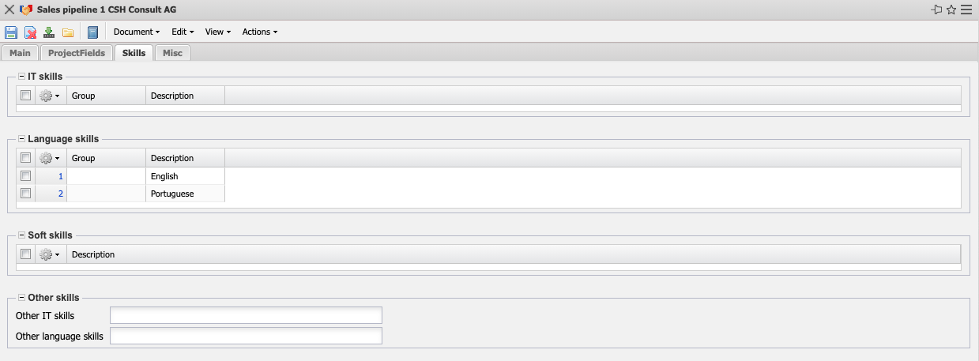
- IT Skills and other IT Skills: In these selection fields you can enter the type of skills (basic, advanced, specialist).
- Language Skills and other Language Skills: The language of the contact is entered in this selection field (German, English, French). Here is defined exactly according to mother tongue, basic knowledge or business fluency.
- Soft Skills: This selection field contains various soft skills such as communication, self-study or team leadership.

Misc
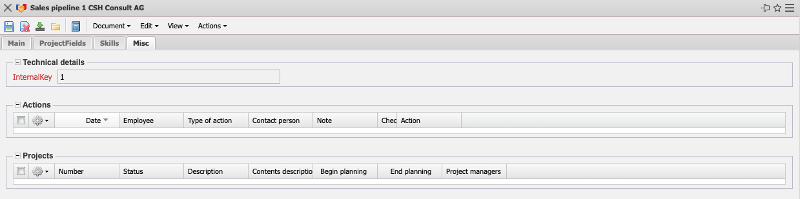
- Technical Details:
  - InternalKey: This number is assigned automatically. It uniquely identifies the sales funnel in the system.
- Actions: Which actions are planned in order to progress with this sale?
- Projects: Here are the projects related to this sale.

Actions
- Create Project: With the help of this action a project can be generated from the sales funnels.

