2.01.14 Campaign Goal
The Campaign Goal mask manages the goals of marketing and sales campaigns in the system. Among other things, the objective, the measured variable and unit as well as the actual values are stored here.
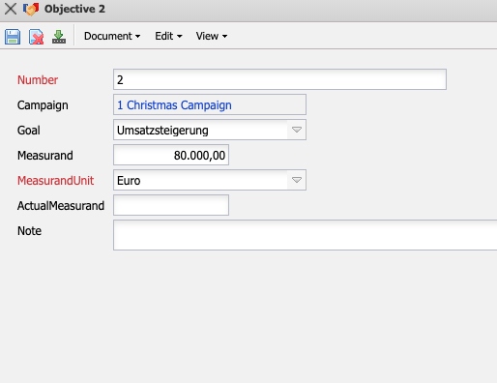
The mask consists of the following elements:
- Number: The Number element clearly identifies the campaign target in the system.
- Campaign: This field identifies the campaign associated with the defined capaign target.
- Goal: In the field Goal, you can assign the targets of the campaign (for example, image enhancement, customer loyalty, customer acquisition, sales increase, and so on) in the collections (see administration guide).
- Measurand: Here you can enter the measure for the campaign objectives.
- MeasurandUnit: Here you can enter the unit of measurement for the target. In the example, the target “customer acquisition” is defined with the measurement “100” and the unit “piece”, i.e. 100 customers are to be acquired.
- ActualMeasurand: This field allows you to enter the actual value for the target of the campaign.
- Comment: This field allows you to enter comments on the target.

