2.01.13 Campaign
The campaign mask manages the marketing and sales campaigns in the system. It lists, among other things, the person responsible for the campaign, the class and status, the time period, the target group and goals, and the key financial figures of the campaign.
The mask consists of the following elements:

General Data
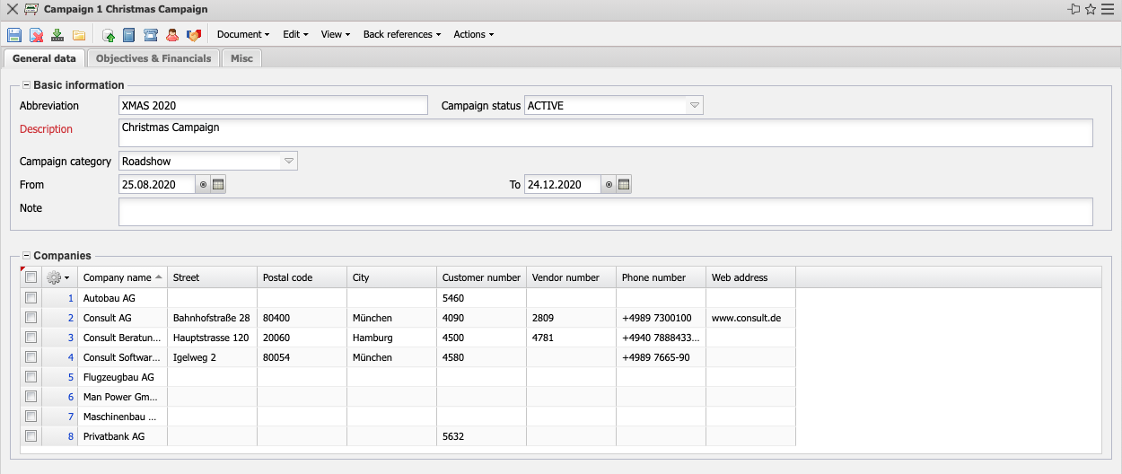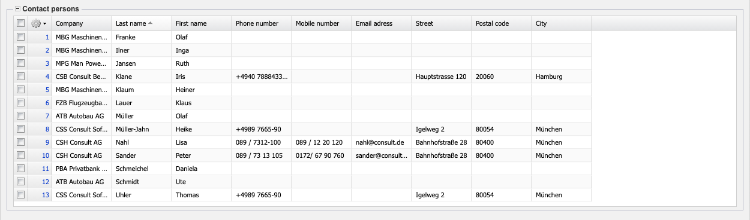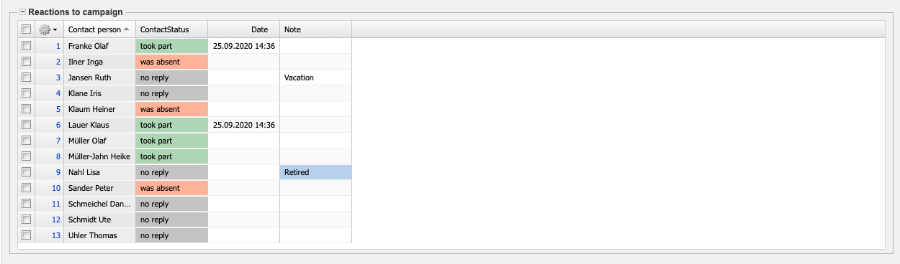
- Basic Information:
  - Abbreviation: A campaign abbreviation can be entered in this field.
  - Status: This field indicates whether the campaign is entered, active or completed. When a new campaign is created, the system enters a default value in this field. Further characteristics (interrupted, terminated) can be defined by the administrator.
  - Description: This field describes the project.
  - Campaign Category: In the type field, defined types of campaigns (for example, e-mail, television, mailing, trade fair, etc.) can be assigned in the collections (see administration guide).
  - From/To: The from field defines the expected start and the To field defines the expected end of the campaign. An entry for these fields is mandatory.
  - Note: This field allows you to enter comments about the customer.
- Companies: This field identifies the companies as target group for the campaign. The contacts can be defined and modified in the contacts mask.
- Contact Persons: This field identifies the contact person at the customer (see mask contact person).
- Reactions to Campaign: In this field, the reactions to the campaign can be inserted for the individual contact persons.

Objectives & Financials
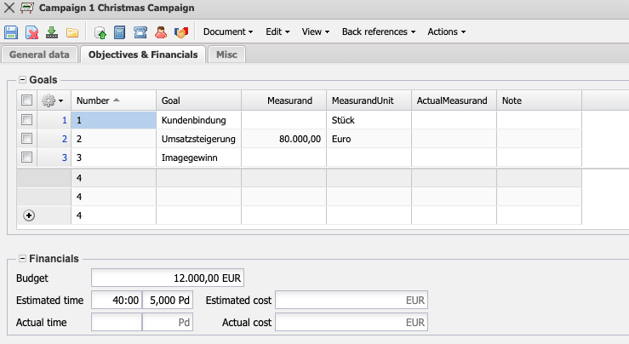
- Goals: Here you can define the goals of the campaign. These goals can be managed in the mask campaign goal.
- Financials:
  - Budget: The budget for the campaign can be defined here.
  - Estimated Effort: This field defines the expected expenses for the campaign.
  - Estimated Cost: The planned costs of the campaign are entered here.
  - Actual Time: Here you can enter the actual expenses of the campaign.
  - Actual Cost: The costs incurred for the campaign are entered here.

Misc
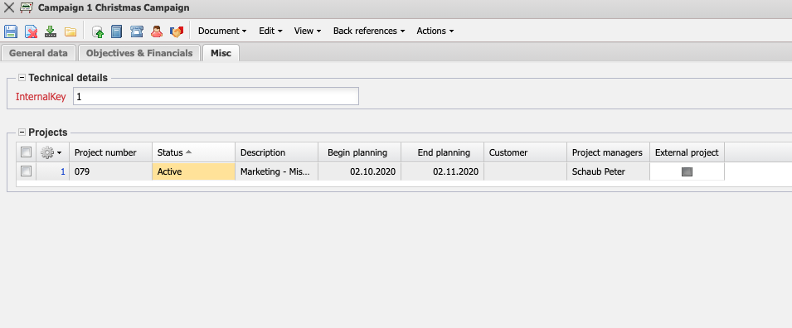
- Technical Details:
  - InternalKey: This alphanumeric field clearly identifies the campaign in the system.
- Projects: Here you can add the projects that have been won through campaigns. The projects can be defined and changed in the project mask.

Actions
The document class contains the following actions:
- Create Actions: This action allows you to create a new action for the campaign from within the system.
- Add Contact Person: This action allows you to add a contact person for the campaign from the system.
- Open Importer: This action opens the Importer, it is used, among other things, to upload files and allows you to view various configurations.
- Add Contact: This action allows you to add a contact for the campaign from the system.
- Create Project: This action allows you to create a new project for the campaign from within the system.

