2.01.12 Company
The mask company manages the business contacts. All information about the contact's company, such as name, address and communication possibilities are stored here. For a clear structuring of the business contacts and for a better analysis, information regarding the category, reference, contact type as well as the corresponding branch can be stored for each business contact. In addition, the currency and the charge rate are managed for customers. This data is required when projects are created and for orders and incoming invoices.
The mask consists of the following elements:

General Data
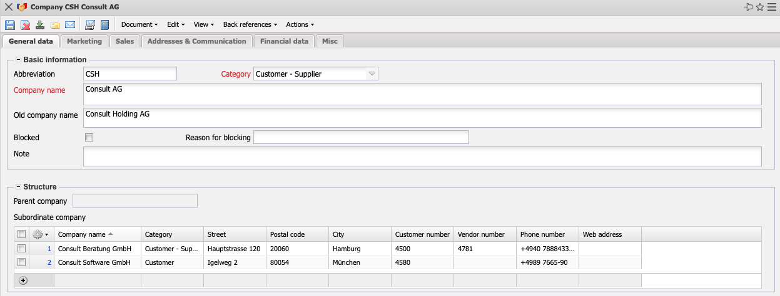
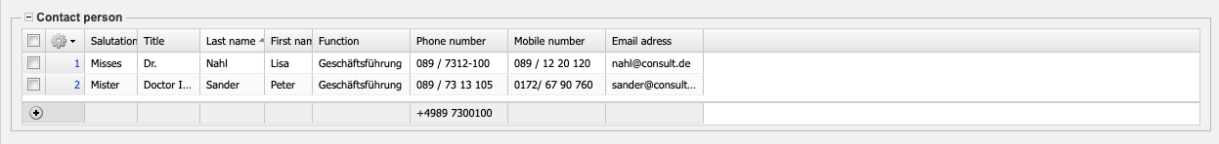
- Basic Information:
  - Abbreviation: An abbreviation for the contact can be entered in this field.
  - Category: In the category field, you can assign defined types of contact (for example, customer, prospect, and so on) in the Collections (see Administration Guide).
  - Company Name and Old Company Name: These alphanumeric fields describe the current company name and, if applicable, the old company name.
  - Blocked, Reason for Blocking: This check mark can be set if the customer is no longer to be used as the sold-to party for a project. The reason for the blockage (insolvency, payment behaviour, ...) can be entered in the next field.
  - Note: This field allows you to enter comments about the contact.
- Structure:
  - Parent Contact: The Parent Contact field characterizes the existence of a parent contact (for example, a holding company) and represents the company structure in projectiles. If the element is not occupied, then the contact itself is a parent contact. This entry is filled automatically when creating subordinate contacts.
  - Subordinate Contact: This element contains a list of all assigned subordinate contacts. After defining “Subsidiary”, these are automatically transferred to the parent contact.
- Contact Person: This field identifies the contact person at the customer (see mask contact person).
- Logo: At this point a company logo can be uploaded for this contact.

Marketing (Sample Implementation)
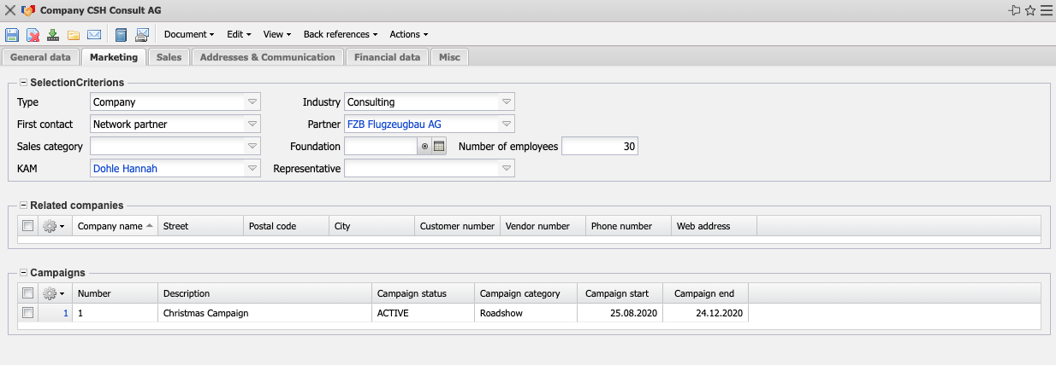
- Criteria & int. Contact Person:
  - Type: Hier kann der Kontakttyp gewählt werden.
  - Industry and Foundation: Here you can enter the branch of the contact and the date of foundation. The industry can be defined in the collections (see administration guide).
  - Initial Contact: The type of initial contact (internet, campaign, cold calling, partner, ...) can be entered here.
  - Partner: Sales partners can be entered here.
  - Number of Employees and Revenue (or Revenue Class): The number of employees and the turnover of the contact can be stored here. These fields can be used as selection criteria (for example, for direct mailings).
  - KAM: The key account manager can be added here.
  - Representation: Here you can enter the customer advisors. These employee(s) are responsible for the contact.
- Known Contacts: Any contacts can be assigned to the defined contact here.
- Campaigns: Here the campaigns concerning this contact are listed.

Sales & Distribution (Sample Implementation)
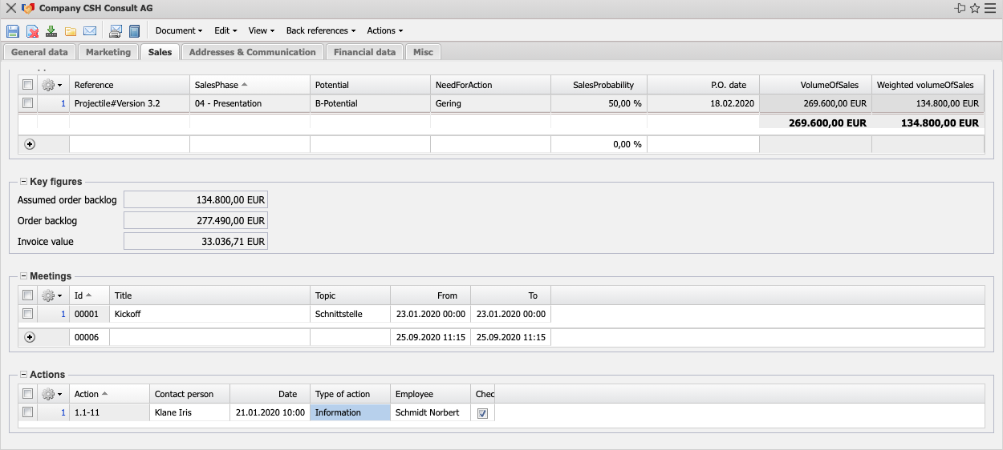
- Opportunities: All sales funnels for the customer are listed here.
- Key Figures:
  - Estimated Order Value: The estimated order value is determined taking into account the order probability.
  - Order and Invoice Value: Here the system lists the order value as the sum of all order confirmations and the invoice value as the sum of all completed invoices of all projects of the customer.
- Meetings: This field defines and notes meetings that have already been held with the customer.
- Actions: This field lists all actions that concern the customer.

Address & Communication
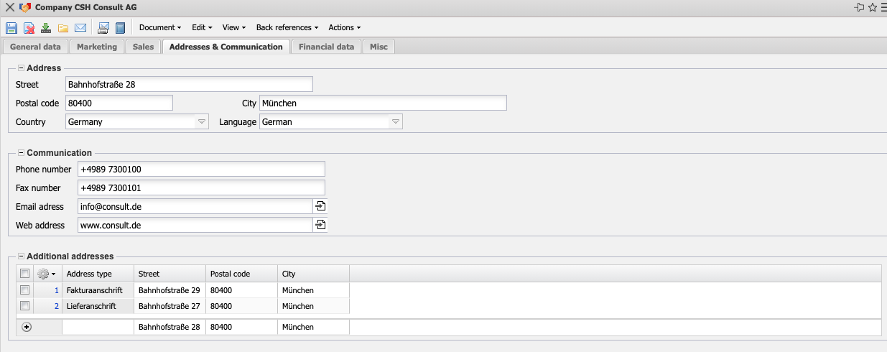
- Address & Communication:
  - Address, Postcode, City and Country: These fields indicate the complete address of the customer and are required for the expenses during the offer and invoice preparation. The countries can be defined and changed in the collections (in the administration menu).
  - Language: The language field defines the customer language. The languages can be defined and changed in the collections.
  - Phone, Fax: These fields indicate the customer's availability by phone and fax.
  - e-mail Address, Web: These fields indicate the customer's e-mail address and URL (Internet address). Clicking on the e-mail address opens the user's default e-mail program with the e-mail address entered and the link to the Web field opens the default browser with the corresponding URL.
- other Addresses: Additional addresses of the customer can be entered here. If the billing address/delivery address differs from the company address, this can be noted here. These addresses are managed in the address mask.

Finances
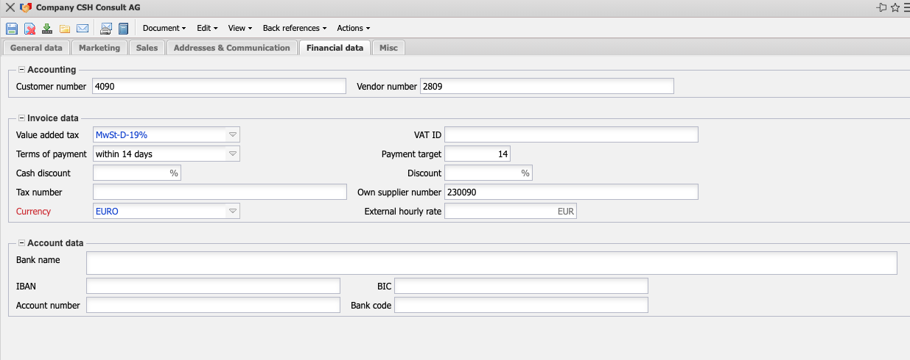
- Financial Accounting:
  - Customer/Vendor Number: The customer number (customer) and/or vendor number (vendor) can be stored here for the financial accounting interface.
- Invoice Data:
- Tax on Sales/Purchases: In this field you enter the tax on sales/purchases as a default value from the selection menu. By default, this field is preset with the tax rate of the country that was assigned in the configuration mask. The VAT can be defined and changed in the sales tax mask. This value is used as default for offers and invoices.
- VAT ID and Tax Number: The VAT ID and tax number (relevant for invoicing) can be defined here.
- Payment Terms and Payment Target: These fields indicate the payment target and the payment terms of the customer.
- Cash Discount: In this field you can indicate whether there is a discount if the customer pays immediately.
- Discount: A discount can be entered in this field.
- Own Supplier Number: Here you can enter the own supplier no. of the defined customer. This number can be used when creating the invoice numbers.
- Currency: This field indicates the general customer currency. By default, this currency applies to all projects for this customer. However, it can be overridden by the project currency. Currencies can be defined and changed in the currency mask.
- External Hourly Rate: This field defines the amount usually charged to the customer for one hour of project work. This amount is only relevant for fixed price projects or for outline agreements and can be overwritten by a project-related hourly rate. The project hourly rate is defined in the project mask; task-related hourly rates can be defined in the task mask (see also pricing).
- Account Information:
- Bank Details (Account Number, Bank Code, Name of Bank, IBAN, BIC): These fields indicate the customer's bank details.

Misc.
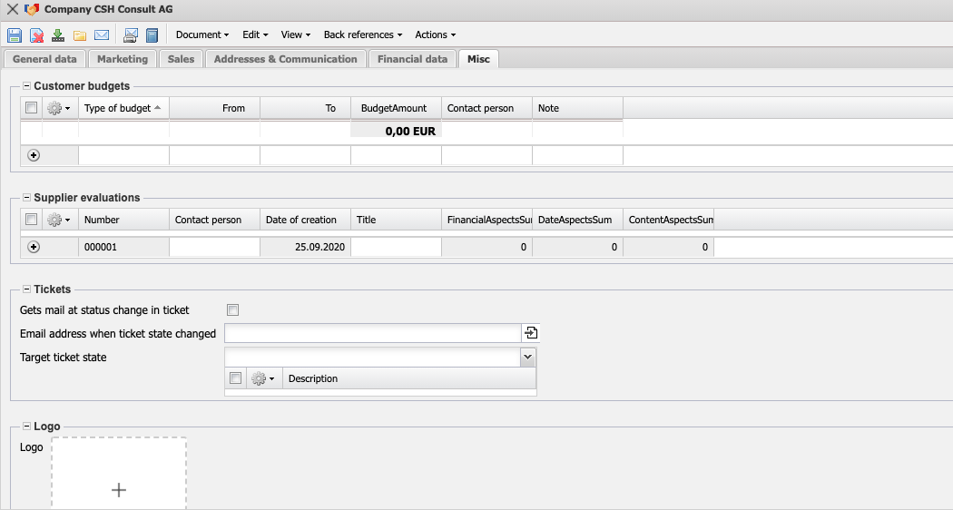
- Customer Budgets: Here you can store customer budgets, for example for blanket orders (as in the example above).
- Supplier Rating: Here you can store supplier ratings for the contact.
- Technical Setting & Details:
- Number: Dies ist eine automatisch generierte Nummer, welche den Kontakt eindeutig im System identifiziert.
- Send an e-mail when Ticket Status Changes: Here you can select whether the customer should be informed by e-mail when the ticket status changes.
- E-Mail for ticket status change: Here you can specify the e-mail to which the notification should be sent.
- Target Status Change Request: Part of the optional ticket system.

Actions
This document class contains the following actions:
- Customer Description: With the help of this action all defined employees can be displayed with their address and actions.
- Create customer-specific Employee Records: This action can be used to define the customer-related employee records.
- Display customer-specific Employee Records: With the help of this action, all defined customer-related employee records are displayed.
- Create customer-specific Resources: This action is used to define the resources on a customer basis.
- Display Resources by Customer: This action displays all defined customer-specific resources.
- Create customer-specific Activities:With the help of this action, price tables for the activities can be defined customer-related (see also pricing).
- Display Activities by Customer: With the help of this action, all defined customer-specific activities can be displayed.
- Create Ticket from Customer: This action can be used to create tickets with the corresponding customer description from within the customer.

