2.01.03 Timed Action
The timed action mask manages the system services for periodic actions in Projectile. This includes, for example, reminders or information by e-mail to individual users or user groups as well as the automatic generation of evaluations and similar processes. A repetition rate and period can be defined here for each time service.
The mask consists of the following elements:

General Data
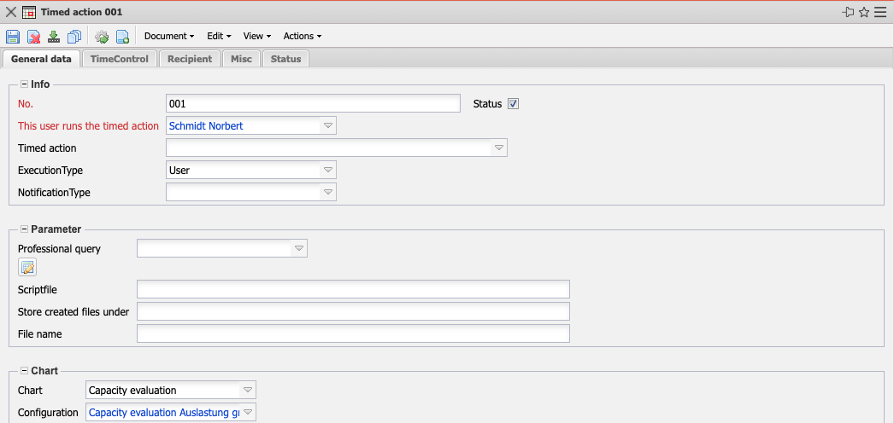
- Info:
  - No.: Number and/or name of the time service.
  - Status: This field indicates whether the time service is active or not.
  - This User runs the Timed Action: This field indicates who is the main user of the time service. When creating evaluations, the rights of the creator are taken into account!
  - Timed Action: The available time services (mainly reminders) can be selected here.
  - ExecutionType: Here you can select whether the time service should be executed as main user or recipient.
  - NotificationType: Here you can select the type of notification.
- Parameter:
  - Professional Query: This selection box lists all available professional searches of the system that have assigned report definitions. If a professional search is assigned here, this query is periodically executed by the time service and sent to the recipients.
  - ScriptFile: A Javascript can be stored here (e.g. for interfaces), which are then saved in the next field).
  - Store created Files under: File directory for the data generated by a Javascript.
  - File Name: Here you can enter the file name.
- Chart:
  - Chart: If the time service is to automate standard evaluations, the evaluation block is assigned here.
  - Configuration: If the “Evaluation” field is filled, a saved standard evaluation of the selected evaluation block is assigned here.

Time Control
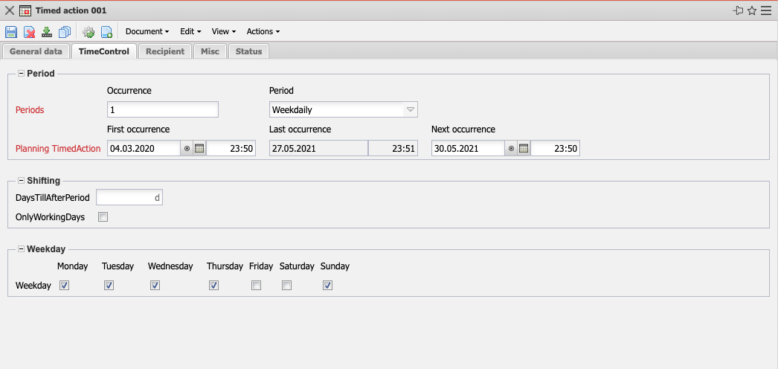
- Period:
  - Repeat after x Periods: This field indicates the number of periods for which the time service is to be repeated.
  - Period: This field indicates the permitted periods for the time service. The user can choose between “annual”, “monthly”, “weekly”, “defined weekdays”, “daily” and “hourly”. The defined time service then starts the processing of a defined action within this period.
  - Difference to Beginning of Period: In this field the difference to the beginning of the period is defined.
  - First, Last & Next Occurence: These fields log the first, last and next call of the time service. These fields are required for the periodic processing of time services.
- Shifting:
- Workdays only: A check mark is placed in this field if the period only applies to workdays.
- Weekday:
  - Weekday (Monday to Sunday): These fields define the weekdays and are only relevant for the period “defined weekdays”. With this option, the defined time service starts on the selected weekday(s).

Recipient
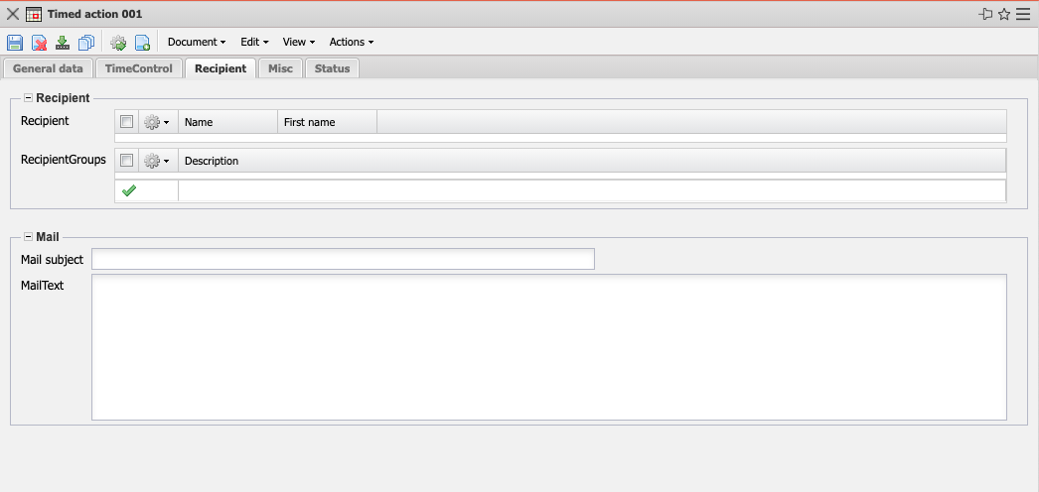
- Recipient:
  - Recipient: This field defines the recipient (based on the Employees of the system) of the time service.
  - Group of Recipients: This field defines the recipients based on the global authorization groups of the time service.
- Mail:
  - Subject: This element allows you to define the subject line for the generated e-mail.
  - Mail Text: A text for the e-mail to be generated can be stored here as a reminder.

Misc
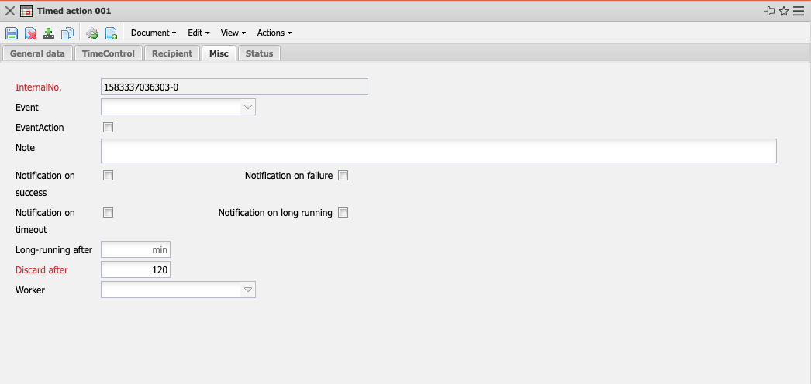
- InternalNo.: ID of the time service.
- Event: This field displays the events that trigger a time service (if the time service is not to be controlled periodically).
- EventAction: This is a special internal flag for event triggered actions.
- Note: This field allows you to enter further comments on this time service.
- Notification on Success/Failure/Timeout/Long Running: Should the administrator be notified if an action was successful or had a problem or ran for too long?
- Long-Running after: After how many minutes should a timed action be considered too long running.
- Discard After: If the system is overloaded with the processing of all time services, you can set in this field how many minutes after the appointment a time service is still valid. If the time service becomes invalid after this period, it is postponed to the next appointment.
- Worker: Workers are parallel processors for timed actions. All timed actions in one worker are performed sequentially. Timed actions in different workers are performed concurrently.

Status
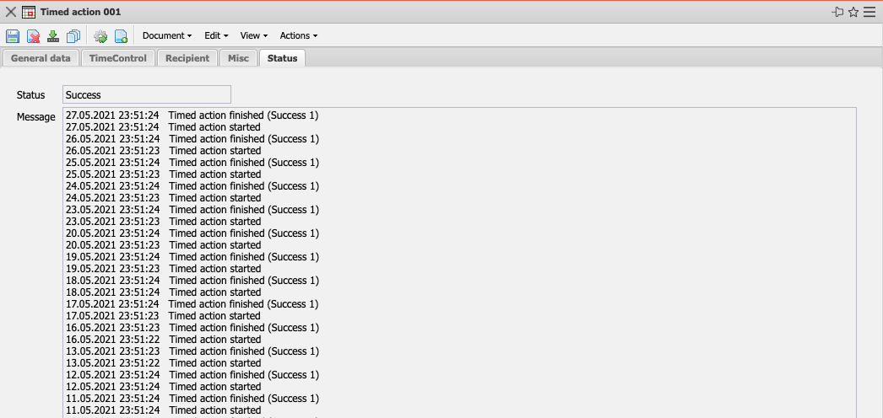
- Status: The status indicates whether the time service has run successfully.
- Message: The messages contain an extract from the time service log data.

Actions
The document class contains the following actions:
- Run Now: This action allows a time service to be executed immediately. The result (of a configured evaluation, for example) is also displayed in the application.
- Set Configuration: This action is used to set the configuration of the time service. If an evaluation is selected as the document type, the corresponding evaluation opens. The desired selection criteria are then defined in the evaluation and the evaluation is saved.

