2.01.02 System
The System mask manages the system parameters in Projectile. This includes the path for the billing documents and other system properties.
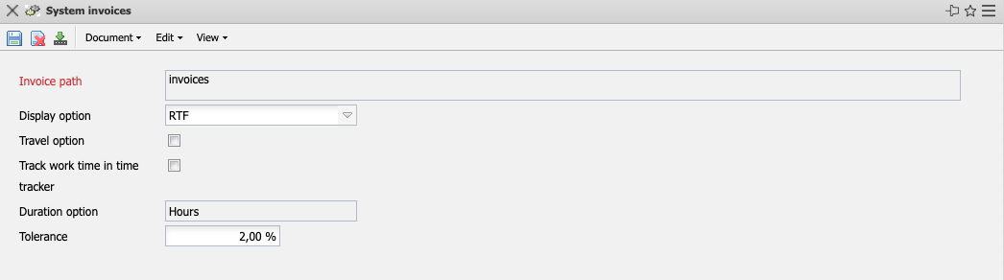

The mask consists of the following elements:
- Invoice Path: This field indicates the path in which the generated billing documents (quotations, invoices and payment reminders) are stored. This path is valid system-wide if no other paths are defined in the XML configurations. However, this specification is only used if no valid paths are entered in the system administration (see also the administration guide).
- Display Option: This element indicates how the billing documents are to be created. For type HTML, an HTML file is created and displayed in the standard browser. For type RTF, a corresponding text file is created and opened with standard word processing. Prerequisite: The corresponding templates exist and are defined accordingly in the system administration (see also the administration guide).
- Travel Option: This field determines how the trips are settled in the invoice. If this field is active, all costs for a trip (for example, the outward and return trip, receipts for accommodations and hospitality, etc.) are transferred as one item in the invoice. If this field is not active, the individual costs of the trip are written as separate items in the invoice.
- Track Work Time in TimeTracker: This field allows you to adjust the time recording component. If this field is activated, working times can also be recorded in the time recording component (see also TimeTracker). Working times are also taken into account in time-related evaluations. If this field is not activated, only project times are recorded in the system and included in the evaluations.
- Duration Option: This option is no longer used.
- Tolerance: This option is no longer used.

